### **AWS Cloud Technology and Services: Beginners Crash Course**

So**,** what is **Amazon Web Services (AWS)**? Simply put, AWS is a cloud computing platform that provides access to various computer resources when needed. It takes care of all the hardware and software for you. A key feature of AWS is that it operates on a pay-as-you-go model, meaning you pay only for what you use.

AWS offers various services, such as data storage, data analytics, machine learning, compute, networking, and databases.

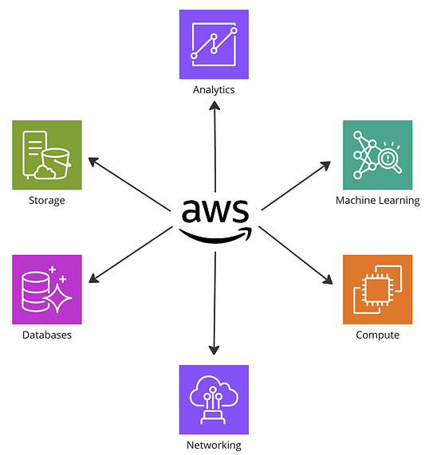Diagram illustrating key AWS services, including Storage, Databases, Analytics, Machine Learning, Compute, and Networking, showcasing the diverse range of solutions AWS provides to support various business needs.  
  
*********************************************************************************************************

**Chapter 1**

### **AWS Infrastructure and Deployment**

Infrastructure refers to equipment and systems needed to run your application, i.e., servers, storage, & networks, while deployment means setting up and running your software/application so that it can be used by others.

AWS offers three deployment options; cloud, hybrid, and on-premises.

**Cloud Deployment**This is where you run applications and services entirely on AWS’s cloud infrastructure.  
In cloud deployment, everything runs on the internet using AWS services.  
It is ideally used whenyou want to manage all your resources, like storage and computing, online without worrying about physical hardware.

**Hybrid Deployment**This method combines your on-site equipment with AWS cloud services to create a flexible and scalable environment.  
It is ideally used when using your existing hardware and AWS resources together.

**On-Premises Deployment**These are private cloud deployments whereby all resources are stored in a private infrastructure owned and managed by you.  
Ideally used when you need complete control over your data and infrastructure, i.e., for security and regulatory reasons.

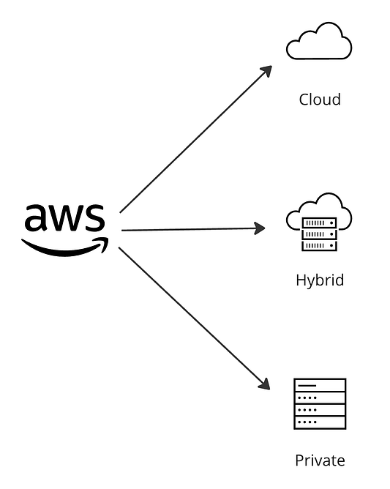Illustration depicting AWS’s deployment models: Cloud, Hybrid, and Private, highlighting the flexibility AWS provides to meet different infrastructure needs.

### **AWS Global Infrastructure**

Now that we understand the basics of infrastructure and deployment, we can explore AWS's global infrastructure. First, let's familiarize ourselves with some key terms.

**Data Centers** are physical facilities that house computer systems and associated components.

**AWS global infrastructure** is the network of data centers that AWS uses to deliver cloud services worldwide.

**Network Latency** refers to the delay in network communication.

**Cached Data** refers to data that is temporarily stored close to the user to speed up retrieval times.

**Redundancy** refers to duplicating hardware or software components to protect against single points of failure.

AWS global infrastructure is designed to provide worldwide accessibility with low latency connections through a network of data centers worldwide. You can think of the AWS Global Infrastructure as a bucket; within that bucket, we have a different hierarchy of components. These components include: Availability Zones, Regions, Edge Locations, Regional Edge Caches, Local Zones, Wavelength Zones, and Outposts

1. **AWS Global Infrastructure: Regions**

Regions are physical geographical locations where AWS operates isolated clusters of data centers. Each region comprises a collection of availability zones that are located in close proximity to one another. Each region also operates independently from the others and includes at least two Availability Zones.

Simple outline of the us-east-1 AWS region, providing a visual framework for understanding regional cloud deployments

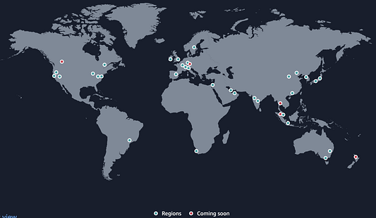Global map showing current and upcoming AWS regions, highlighting the expansive reach and ongoing growth of AWS’s global infrastructureSimple outline of the us-east-1 AWS region, providing a visual framework for understanding regional cloud deployments

1. **AWS Global Infrastructure: Availability Zones (AZs)**

Within regions, we have AZs that are made up of one or more data centers. AZs are designed to provide high availability and fault tolerance, which helps keep services running even if one data center experiences issues. Availability zones are interconnected using high-speed private links. Low latency links between AZs are used by many AWS services to replicate data for high availability and resilience purposes

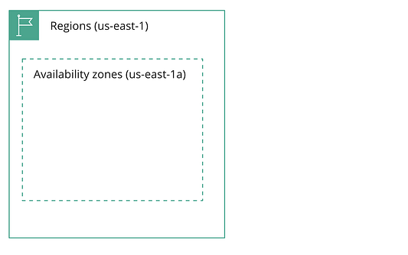Basic representation of the us-east-1 AWS region highlighting an Availability Zone (us-east-1a), indicating the foundational structure for deploying cloud resources

1. **AWS Global Infrastructure: Local Zones**

Local zones are extensions of AWS regions designed to bring compute, storage, and database services closer to users. Their purpose is to ensure low-latency access in specific geographic areas, thereby enhancing end-user performance.

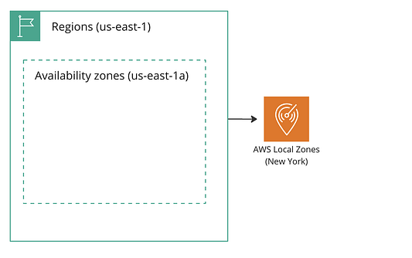Diagram illustrating the us-east-1 AWS region with an Availability Zone (us-east-1a) and its connection to AWS Local Zones in New York for reduced latency and improved local performance.

1. **AWS Global Infrastructure: Edge Locations**

Edge locations are global data centers that store cached copies of data. Their purpose is to enhance content delivery by reducing latency and enabling faster information retrieval closer to users.

1. **AWS Global Infrastructure: Wavelength Zones**

These are specialized AWS locations situated within the data centers of telecommunication companies, positioned near users at the edge of the 5G network. You might wonder, "Why are they located in telecom companies’ data centers?" The reason is that telecom companies have widespread data center networks. By integrating AWS services into these facilities, AWS can utilize existing infrastructure to provide faster and more reliable services.

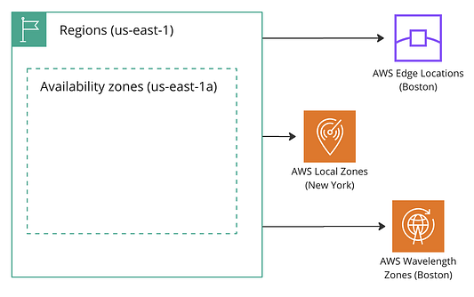Overview of the us-east-1 AWS region showing the relationship between an Availability Zone (us-east-1a) and its connected AWS Edge Locations (Boston), AWS Local Zones (New York), and AWS Wavelength Zones (Boston) to provide low-latency services.

1. **AWS Global Infrastructure: Outposts**

AWS Outposts bringd the capabilities of the AWS cloud to your on-premises data center. They utilize the same hardware found in AWS data centers, enabling you to employ native AWS services, tools, and APIs as if you were operating directly within AWS infrastructure. As a fully managed solution, AWS Outposts relieve you from the responsibilities of patch management and software updates. AWS ensures that your Outposts are maintained, patched, and updated as necessary.

**Global Accelerator**AWS Global Accelerator is a service designed to optimize the path your users take to your applications, improving the availability and speed of your applications by leveraging the AWS global network.

**Sample Global Architectural Patterns in AWS**

In this section, we'll explore visual representations of various architectures from the infrastructures we've discussed.

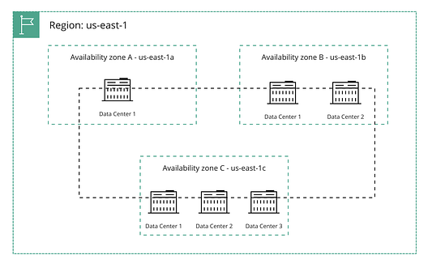Representation of the us-east-1 AWS region illustrating three Availability Zones (us-east-1a, us-east-1b, us-east-1c), each containing multiple data centers to ensure high availability and fault tolerance

The region (us-east-1—Northern Virginia) is a large geographical area containing multiple Availability Zones(AZs). AZs are subsections of the AWS region designed to be isolated from failures in other AZs. Each AZ can include one or more data centers. This region has three depicted AZs: us-east-1a, us-east-1b, and us-east-1c.

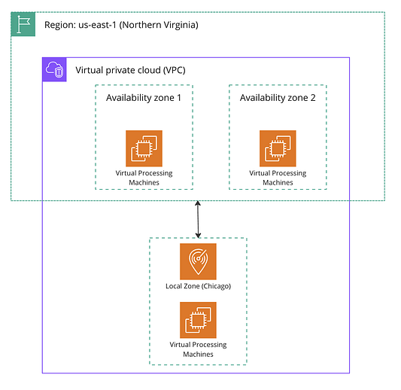Virtual Private Cloud (VPC) setup in the AWS us-east-1 (Northern Virginia) region, showing multiple Availability Zones and a Local Zone in Chicago to enhance redundancy and reduce latency.

The illustration above shows a **Virtual Private Cloud (VPC)** within the AWS region us-east-1 (Northern Virginia). The VPC spans multiple Availability Zones (AZs) and includes a Local Zone. Local Zones bring AWS services closer to users to support latency-sensitive applications.

An **Amazon Virtual Private Cloud (VPC)** is your own isolated section of AWS where you can launch AWS resources.

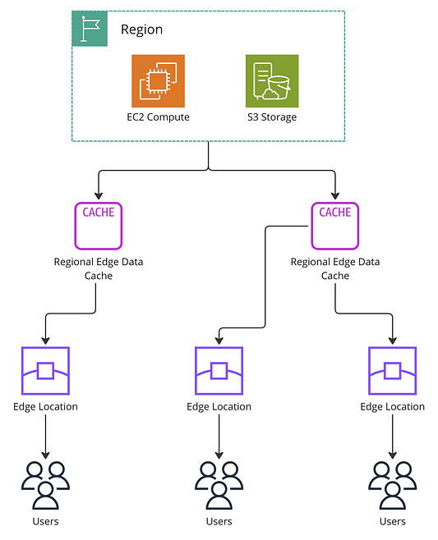Content Delivery Network (CDN) Architecture with Regional Edge Data Cache and Edge Locations

A **Content Delivery Network (CDN**) is a system of distributed servers that delivers web content and applications to users based on their geographic location. The main goal is to provide high availability and performance by distributing the service closer to end-users' locations.

**Amazon Elastic Compute Cloud(EC2)** is a web service that provides resizable compute capacity in the cloud. Think of it as powerful computers in the cloud.

**Amazon Simple Storage Service(S3)** is a service for storing files and data in the cloud, similar to an online storage drive.

**Regional Edge Data Cache** is a middle layer where popular content is stored closer to edge locations to make it quicker to access. It acts as a temporary storage for frequently requested data.

**Edge Locations** are small data centers located near users. These locations store cached content to deliver it to users quickly, reducing the time it takes to load websites or access applications.

**Users** are people who are using the internet to access websites or applications. Their requests are routed to the nearest edge location to get the content faster.

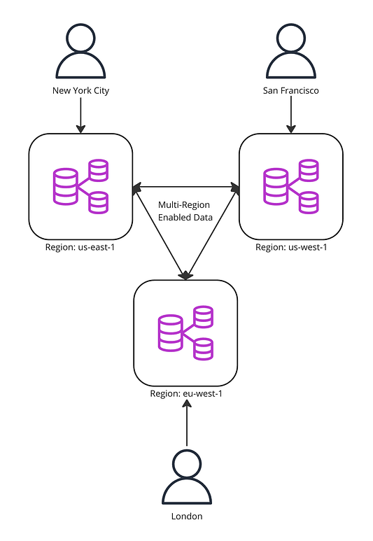Multi-Region Data Replication for Global Access

This diagram illustrates how data is replicated across multiple AWS regions to ensure high availability, low latency, and redundancy for users located worldwide. Users access the data from the area closest to them, which reduces latency and improves access speed.

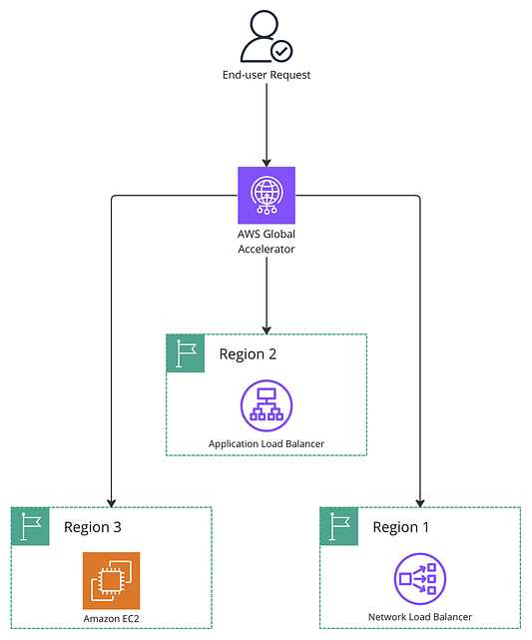Global Load Balancing with AWS Global Accelerator

This diagram illustrates how AWS Global Accelerator directs end-user requests to the optimal AWS region, using different types of load balancers to ensure efficient traffic distribution and high availability.

The Application Load Balancer handles and distributes HTTP/HTTPS traffic and offers advanced routing features. While the Network Load Balancer handles and distributes TCP/UDP traffic and is optimized for high performance and low latency.

In this illustration, the AWS Global Accelerator uses the AWS global network to route traffic to the nearest and healthiest endpoints.  
  
*********************************************************************************************************

**Chapter 2**

### **AWS Connectivity and Infrastructure**

Now that we've covered deployment and global infrastructure, let's explore how to connect to AWS services and provision resources within AWS.

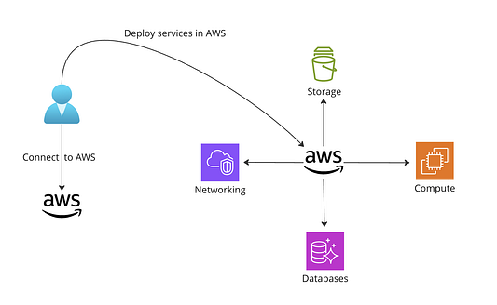Visualizing AWS Service Deployment: From connecting to AWS to utilizing essential services like Storage, Compute, Networking, and Databases.

There are primarily three ways to connect to AWS services: Public internet, AWS Direct Connect, and AWS VPN.



**Public Internet**Public Internet allows connection to the AWS user interface from any internet-connected device. It’s an easy and cost-effective method. This method is ideal for quick and straightforward access to AWS services and is best suited for individual developers, small businesses, and educational institutions where advanced security is not a primary concern.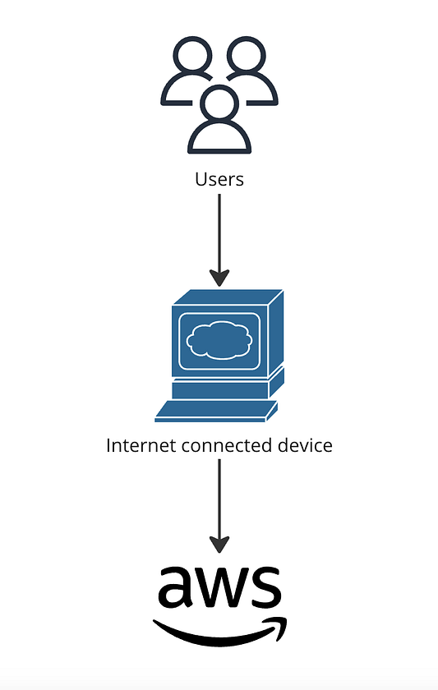Users connect to AWS services using their internet-connected devices over the public internet

**AWS Direct Connect**AWS Direct Connect offers a direct link to AWS data centers, providing a dedicated network connection that bypasses the public internet. This method is more secure and reliable, making it ideal for enterprises that require consistent network performance. It ensures lower latency, enhanced security, and dependable network performance. AWS Direct Connect is particularly suitable for enterprises and organizations that need a stable and secure connection to support their operation

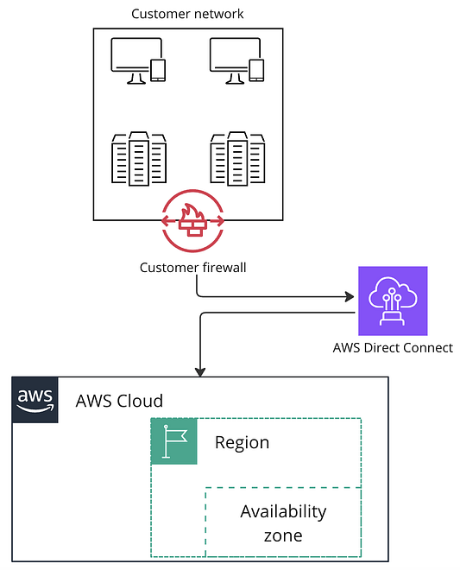A customer’s network connects to AWS via AWS Direct Connect, bypassing the public internet for a dedicated, more secure connection.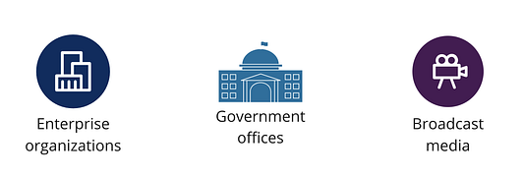AWS Direct Connect is utilized by enterprise organizations, government offices, and broadcast media

**AWS VPN**AWS VPN provides a secure method of connecting to AWS resources using a Virtual Private Network. This option creates an encrypted connection between on-premises environments and AWS, enabling remote access from anywhere. It combines security with flexibility, making it an ideal choice for remote work and distributed teams. AWS VPN is cost-effective and well-suited for organizations seeking secure, flexible access to AWS resources from multiple locations.

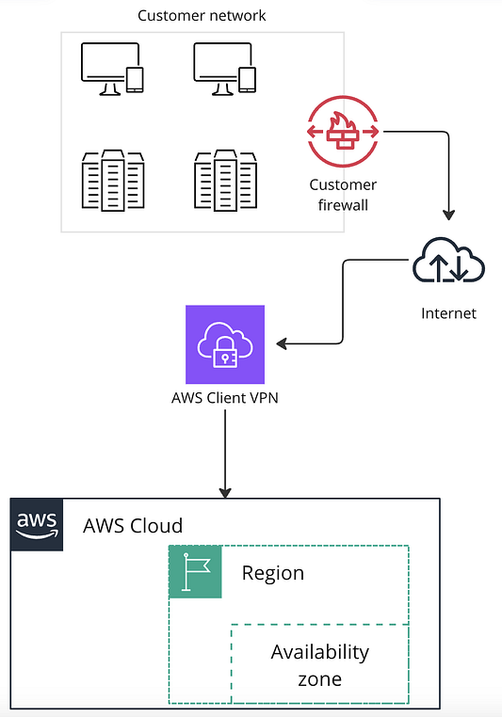How a customer network connects to AWS through an AWS Client VPN.

Now that we've discussed how to connect to AWS, let’s explore what you can do once you are inside the AWS environment.

**Infrastructure as Code (Iac)**

A common reason for connecting to AWS is to deploy services in the cloud. In AWS, one can deploy services using a tool called Infrastructure as a Code (IaC). IaC is a method for provisioning and managing AWS deployments using code templates.

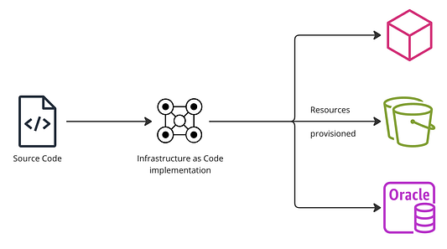How Infrastructure as Code (IaC) works is by converting source code into automated provisioning of resources.

**Why Use IaC?**

Infrastructure as Code (IAC) enables developers to deploy new resources using code, supports version control to maintain a history of configurations, and facilitates consistent and repeatable deployments.

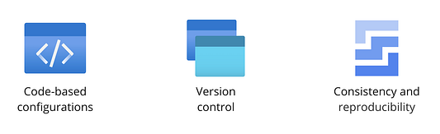Code-based configurations, version control, and consistency and reproducibility are key advantages of using IaC.

**AWS CloudFormation**

AWS CloudFormation is a service that allows you to implement infrastructure as code capabilities in AWS. It supports JSON and YAML templates for creating code-based configurations, allows for version control of the templates, and supports Continuous Integration and Continuous Deployment(CI/CD) capabilities.

AWS CloudFormation

To use CloudFormation, you start by creating JSON or YAML templates that contain code for the resources you need configured and their configurations. You then upload the template to an S3 bucket that is accessible to CloudFormation, which will read the template code from the bucket and then provision all the resources in their respective configurations as instructed in the template.

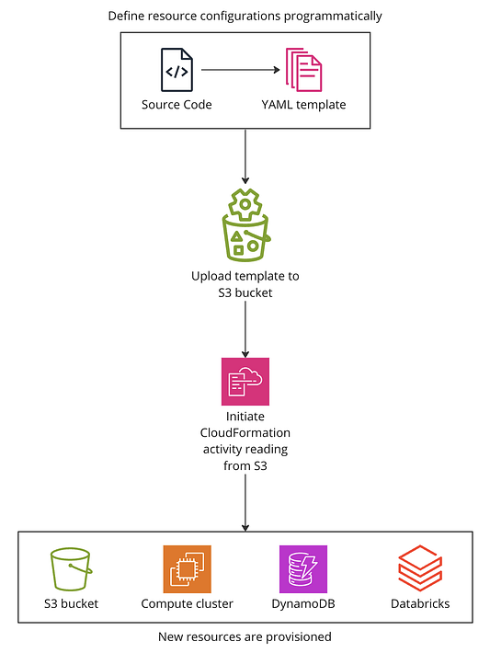Defining resource configurations programmatically using YAML templates and AWS CloudFormation to provision new resources.

*********************************************************************************************************

**Chapter 3**

### **AWS Storage Solutions**

Here, we’ll explore storage solutions provided by AWS, storage lifecycle policies, and backup services.

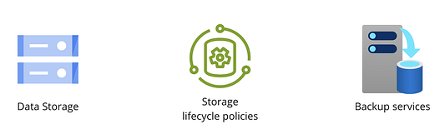AWS storage solutions: Data Storage, Storage Lifecycle Policies, and Backup Services to manage and protect data efficiently.

Cloud computing relies heavily on data storage and AWS provides various storage options suitable for various needs and use cases. These options ensure secure data management and retrieval in the cloud.

**Storage types in AWS**

We have four types of storage in AWS; Object Storage, Block Storage, File Storage, Cache Storage

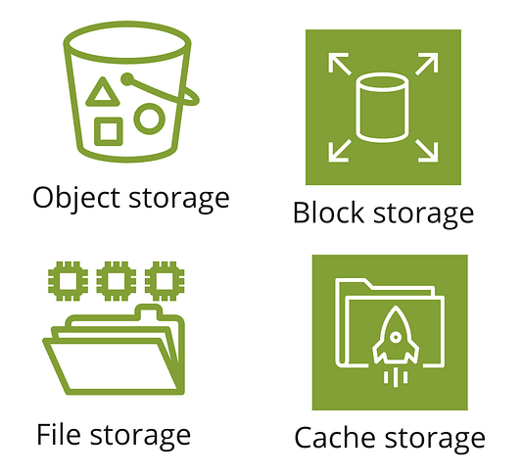Overview of AWS storage solutions: Object Storage, Block Storage, File Storage, and Cache Storage, each designed to meet different data management and retrieval needs.

1. **Object Storage**

It is a storage architecture that manages and organizes data as discrete units called objects. Key features of objects include.

a) Horizontal scaling

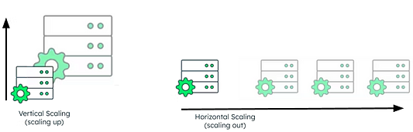Vertical Scaling involves upgrading a single server by adding more resources, which can improve performance but has limitations in capacity and fault tolerance. Horizontal Scaling, on the other hand, involves adding more servers (nodes) to distribute the load, providing greater capacity, fault tolerance, and flexibility to handle increased data and traffic.

Horizontal scaling means adding more servers (storage nodes) to handle more data and requests. In object storage, a storage node is a server or device that stores data and contributes to the overall storage infrastructure.

Vertical scaling, on the other hand, is where you increase the capacity of an existing machine by adding more resources (CPU, RAM, storage).

b) Metadata Management

Metadata is data about data. Each object is created with its own metadata, which can include details such as date, content type, access permissions, and custom tags defined by the user.

Rich metadata capabilities make it easier to organize, search, and manage large datasets. It also allows for efficient categorization and retrieval of data based on various attributes, enhancing data management and analysis.

c) Storing unstructured data

Unstructured data is data that has not yet been ordered in a predefined way. Some common examples are text files, video files, reports, email, and images. Unstructured data is often large, complex, and difficult to manage using traditional databases. Object storage is well-suited for storing unstructured data because it can handle large volumes of data with diverse formats without requiring a rigid schema.

*In contrast, structured data has a standardized format for efficient access by software and humans alike. It is typically tabular with rows and columns clearly defining data attributes.*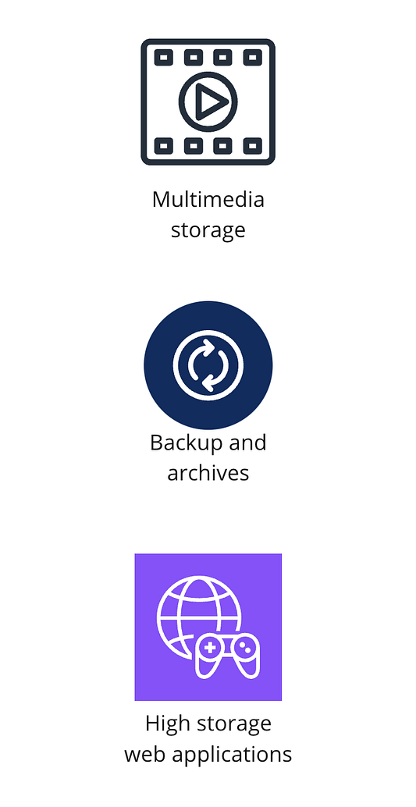Common Use Cases of Object Storage

**Amazon Simple Service Storage (Amazon S3)**

Amazon S3 is an object storage service provided by AWS that offers high scalability, data availability, security, and performance. It is available in all regions.

**Scalability:** You can store any amount of data in S3. It is fully elastic, which means there is no need to provision storage, it automatically grows and shrinks as you add and remove data.

**Durability and availability:** S3 is designed to provide 99.999999999% data durability and 99.99% availability by default, backed by the most robust Service Level Agreements(SLA) in the cloud. An SLA is a formal contract between a service provider and the customer that specifies the expected level of service.

**Security and data protection:** S3 is secure, private, and encrypted by default.

**Lowest price and highest performance:** S3 provides multiple storage classes for different use cases, the best price-performance for any workload, and automated data lifecycle management, so you can store massive amounts of frequently, infrequently, or rarely accessed data cost-efficiently.

**How Amazon S3 Works**

Amazon S3 stores data as objects within buckets. A bucket is a container for objects, while an object is a file and any metadata that describes the file. Each bucket hosted in an AWS account contains multiple objects. Each object in an Amazon S3 bucket consists of data, a unique key (identifier), and metadata. The data represents the actual content, the unique key ensures each object can be uniquely identified and retrieved, and the metadata provides additional information about the object, such as its properties and management details.

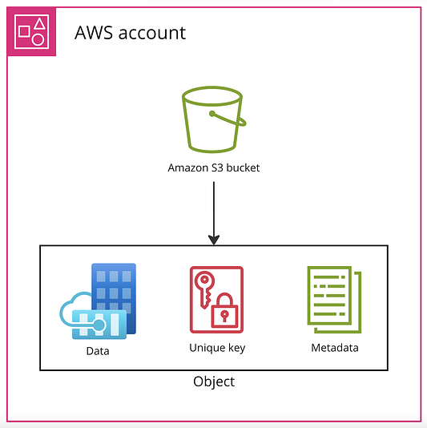Structure of an Amazon S3.

**Storage Classes in S3**

Amazon S3 offers six storage classes designed to cater to varying latency and data access requirements: S3 Standard, Intelligent-Tiering, One Zone-Infrequent Access (One Zone-IA), Glacier, Glacier Deep Archive, and Outposts.

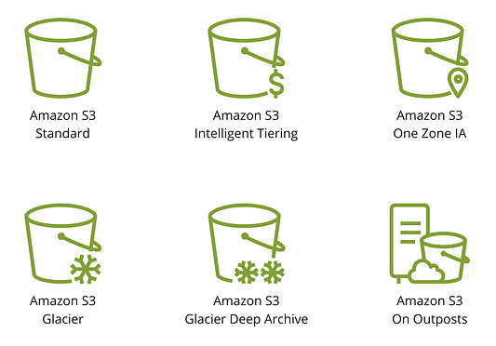Amazon S3 Storage Classes

**Amazon S3 Standard**

This is the most used class suitable for data that needs to be accessed frequently. It is durable, scalable, and available in all AWS regions.

**Amazon S3 Intelligent Tiering**

Optimizes cost by moving objects automatically between tiers(classes) based on data access patterns.

**One Zone-Infrequent Access (IA)**

Operates in a single availability zone and is therefore cost effective and suitable for data that does not require redundancy. It is ideal for infrequently accessed data that can be easily reproduced.

**Amazon S3 Glacier**

Glacier is a low-cost, archival storage option for infrequently accessed data that can withstand long retrieval times ranging from minutes up to a few hours.

**Amazon S3 Glacier Deep Archive**

Glacier Deep Archive has the lowest storage cost and the longest retrieval times. It is most suitable for infrequently accessed data backups.

**Amazon S3 Outposts**

Outposts extend storage to on-premises data, enabling a hybrid architecture for seamless on-premises and cloud data integration. Essentially, it brings the cloud storage capabilities of S3 to your local **environment** (physical hardware located in your own data center or on your premises).

1. **Block Storage**

Block storage divides storage into fixed-size blocks, each with a unique address. Uploaded data is segmented(divided into smaller, manageable pieces or blocks) to create a lookup table for block identification during retrieval. It’s commonly used for transactional stores and applications with intensive read-write requirements.

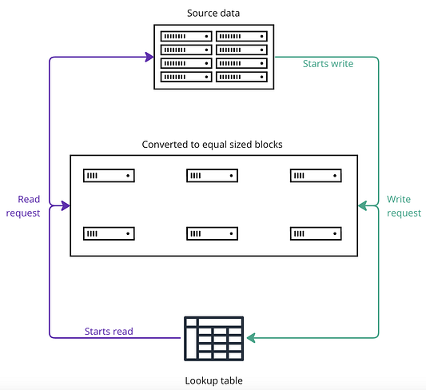This image illustrates the process of data segmentation and retrieval. Source data is divided into equal-sized blocks during a write request. These blocks are stored and mapped using a lookup table for easy identification. When a read request is made, the lookup table is used to locate and retrieve the necessary blocks, which are then reassembled to fulfill the request

**Amazon Elastic Block Storage (EBS)**

Amazon Elastic Block Storage(EBS) is a block storage service designed for compute services. It provides block-level storage volumes, which act like hard drives, organizing data into fixed-size blocks. It is designed to be used with AWS compute services such as Amazon EC2 (Elastic Compute Cloud). It offers both HDD and SSD options. EBS volumes are directly attached to EC2 instances, providing localized storage. This means that the storage is closely tied to the compute instance, ensuring 99.999% application availability.

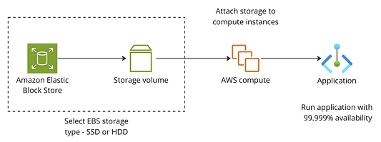Amazon EBS provides block storage volumes in SSD or HDD formats. These volumes are attached to AWS compute instances (such as EC2) to provide localized storage. This setup supports applications with 99.999% availability, ensuring high performance and reliability.

1. **File Storage**

File storage allows for hierarchical data storage in directories and subdirectories, offering simultaneous read-write access to multiple users and applications. It stores meta data for faster retrieval.

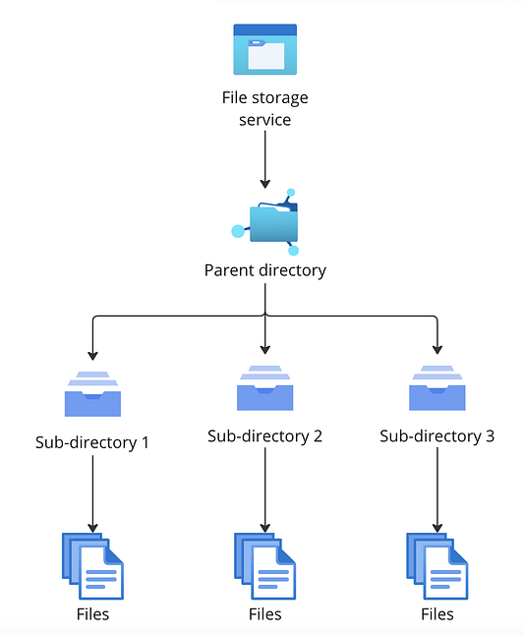Hierarchical Data Storage

**Amazon Elastic File System (Amazon EFS)**

Amazon EFS is a file-level, fully managed storage that can be accessed by multiple EC2 instances concurrently. It is designed for both on-premise and cloud data. It’s used in DevOps for code sharing, in content management systems, and for parallel processing in data science experiments.

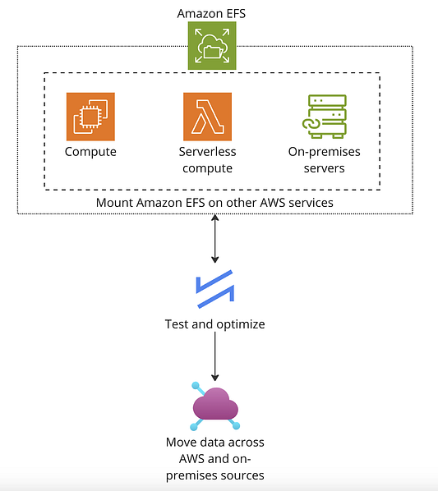How Amazon EFS integrates with AWS services and on-premises servers. EFS can be mounted on compute instances, serverless compute (AWS Lambda), and on-premises servers, allowing seamless data movement and configuration optimization. AWS Lambda enables running code without server management.

1. **Cache Storage**

Cache storage stores frequently accessed data in a quickly retrievable location, speeding up application response time and reducing server load by minimizing data retrieval from original source.

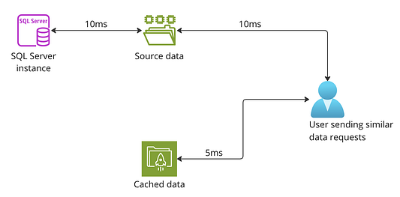how caching reduces data retrieval time. Initial requests to the SQL Server take 10ms, while subsequent requests use cached data, reducing the time to 5ms, thereby improving performance.

**Amazon ElasticCache**

ElastiCache provides cache storage in AWS, operating atop data stores to deliver cached data to applications. It is commonly used for storing web app session data and accelerating real-time analytics.

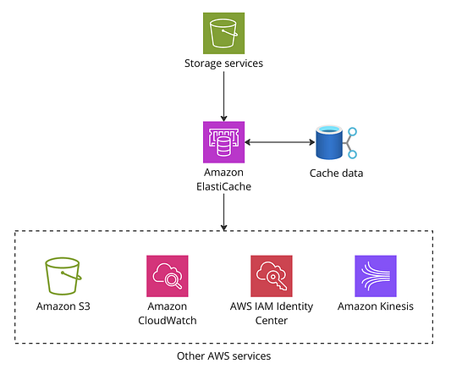ElastiCache caches data from storage services to speed up access for applications. It interacts with services like Amazon S3, Amazon CloudWatch, AWS IAM Identity Center, and Amazon Kinesis to enhance performance and scalability.  
  
*********************************************************************************************************

**Chapter 4**

**Compute in AWS**

Compute services (Infrastructure-as-a-Service (IaaS)) supply cloud based servers that provide computational resources, such as virtual machines (VMs), on-demand. They allow users to run applications and manage workloads without investing in physical hardware or power backup.

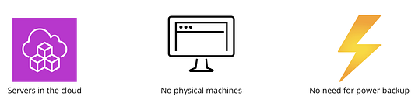Benefits of Cloud Servers

**Amazon Elastic Compute Cloud (EC2)**

Amazon EC2 provides compute capabilities in AWS. Each individual EC2 machine is called an instance and can be scaled up or down based on needs. Different use cases necessitate different types of instances. EC2 instances seamlessly integrate with other AWS services like storage and databases.

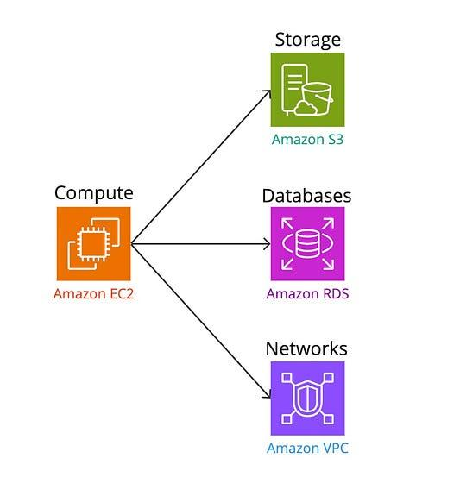The relationship between Amazon EC2 for compute, Amazon S3 for storage, Amazon RDS for databases, and Amazon VPC for networks.

**EC2 Instance Type Categories**

There are six categories of EC2 instances for specialized use-cases: General Purpose,Compute optimized, Memory optimized, Storage optimized, Accelerated computing, and High Performance Computing (HPC) optimized.

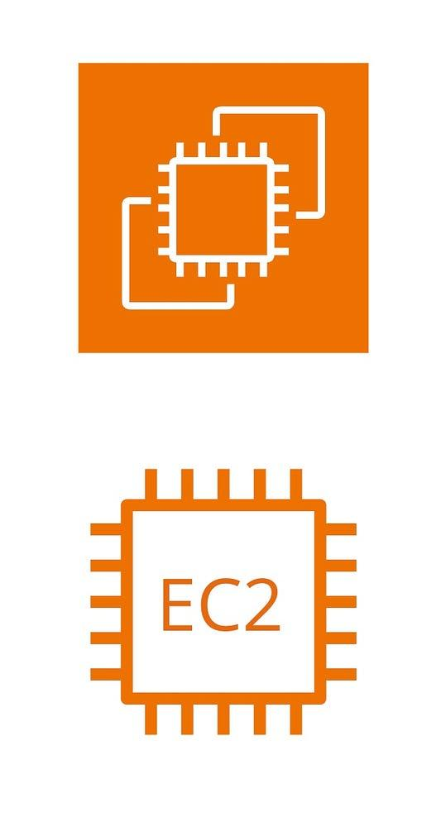Amazon EC2: The core compute service in AWS, providing scalable virtual server instances for a variety of workloads

1. **General Purpose**

General-purpose instances are designed to handle a mix of tasks involving of computing power, memory, and networking resources. They are commonly used for things like running websites and managing code repositories.

General Purpose EC2 Instances: Balanced compute, memory, and networking resources for a variety of workloads

1. **Storage optimized instances**

Storage optimized instances are built for handling lots of data quickly, especially for tasks that involve reading and writing large amounts of data. They are ideal for uses like storing big datasets in a data warehouse or reorganizing large databases.

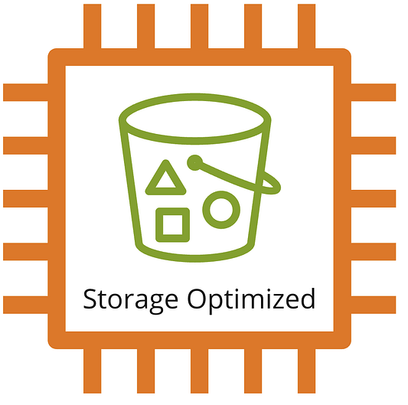Storage Optimized EC2 Instances: High-performance storage solutions for large datasets and data-intensive applications.

1. **Compute optimized instances**

Compute optimized instances are made for tasks that need a lot of processing power, such as running scientific simulations or financial models.

Compute optimized instance

1. **Memory optimized instance**

Memory optimized instances are built for tasks that need a lot of memory but not necessarily a lot of storage, such as analyzing real-time data streams or generating closed captions.

Memory optimized instance

1. **Accelerated computing instances**

Accelerated computing instances include special hardware like Graphics Processing Units (GPUs) and Field Programmable Gate Arrays (FPGAs), making them ideal for tasks such as deep learning and graphics rendering.

Accelerated computing

1. **High Performance Computing (HPC) optimized instances**

HPC optimized instances are designed for tasks that always need a lot of computing power, like weather forecasting or crash simulations, and help to optimize costs for these high-demand applications.

HPC optimized

**Load balancing in AWS**

An important concept in designing effective compute resources is load balancing. Load balancing evenly distributes traffic among multiple EC2 instances, preventing server overloads and ensuring high availability and efficient horizontal scaling. AWS supports four types of load balancers: **Classic**, **Network**, **Application**, and **Gateway load balancers**.

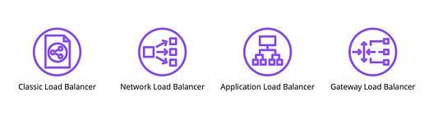Types of load balancers in AWS.

**How load balancing works?**

1. The process starts with users sending processing requests.

*User Requests*: Customers visit your online store and start browsing different product pages. Each action they take, such as clicking on a product or adding an item to their cart, sends a request to your server.

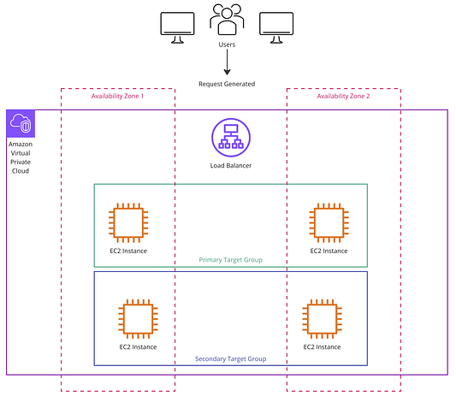

1. The requests hit the load balancer.

These requests first go to the load balancer instead of directly hitting your servers. The load balancer acts as a gatekeeper, receiving all incoming traffic.

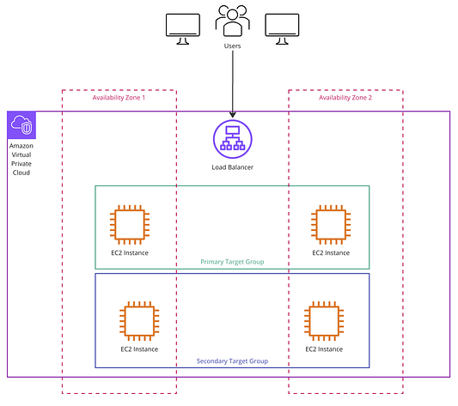

1. The load balancer activates the primary target group to fulfill the user request

*Primary Group Activation*: The load balancer forwards these requests to the primary group of EC2 instances (servers). This group is set up to handle a certain amount of traffic efficiently. These instances start processing the requests, delivering the product pages and managing shopping carts.

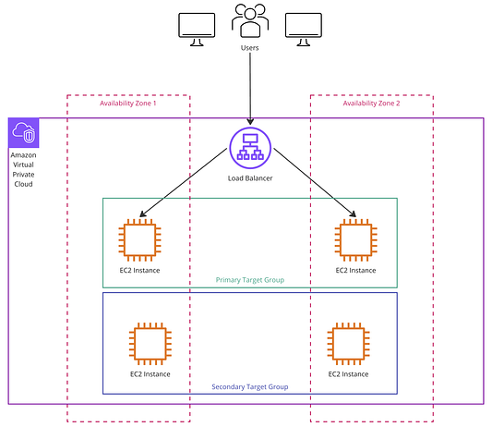

1. If the traffic exceeds the capacity of the primary target, the load balancer activates the secondary group and distributes traffic evenly among all instances.

*Handling High Traffic:* “Traffic” here refers to the volume of user requests coming to your website. If the number of requests (traffic) increases and the primary group of instances reaches its capacity (i.e., they can’t handle more requests efficiently), the load balancer will activate the secondary group of EC2 instances.

*Secondary Group Activation***:** The secondary group of EC2 instances starts up, and the load balancer begins to distribute the additional requests to these new instances. This helps in managing the high traffic by spreading the load across more servers, ensuring that no single server becomes overloaded

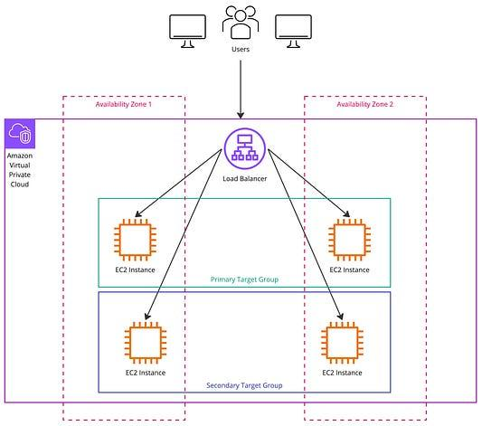

**Compute elasticity**

Elasticity is a crucial concept in computing that provides systems with the flexibility to automatically scale resources up or down according to demand. This adaptive scaling ensures that your system expands its capacity during peak periods and conserves resources when demand wanes, thereby optimizing both costs and performance. Amazon EC2 instances leverage this elasticity through the use of EC2 Auto Scaling.

**EC2 Auto Scaling**

This is an AWS service that automatically adjusts the number of active EC2 instances based on real-time usage. It helps reduce costs by preventing over-provisioning (having more resources than necessary) and ensures that your application always has the right amount of resources to handle current demand.

**How Does Auto-Scaling Work?**

1. Users send requests

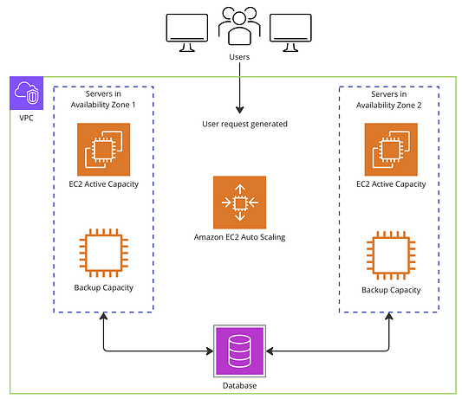User Requests

1. These requests are received by the EC2 auto-scaling service

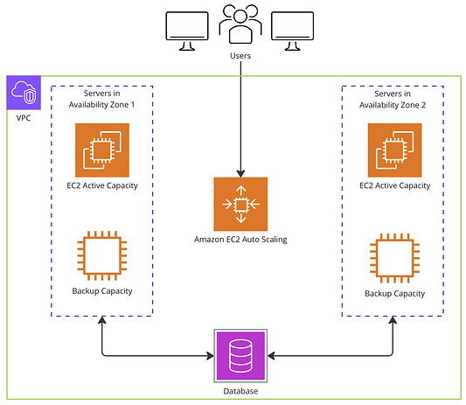Request Reception

1. The auto-scaling service routes these requests to the available active EC2 instances.

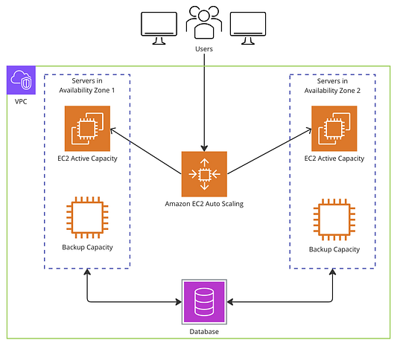Routing Requests

1. If the demand exceeds the capacity of the existing instances, the auto-scaling service creates new EC2 instances to handle the increased demand.

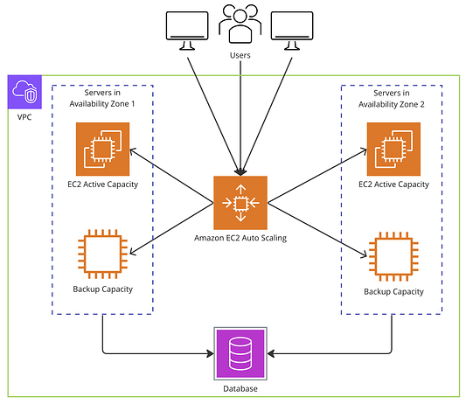Handling Increased Demand

1. If the demand decreases, the auto-scaling service turns off the extra instances to save costs.

**Reducing Instances**

**Load Balancing vs. Auto-Scaling**

*Load Balancing* distributes traffic evenly across an existing set of EC2 instances, ensuring no single instance is overloaded. By balancing the load among all available instances, it helps maintain high availability and performance.

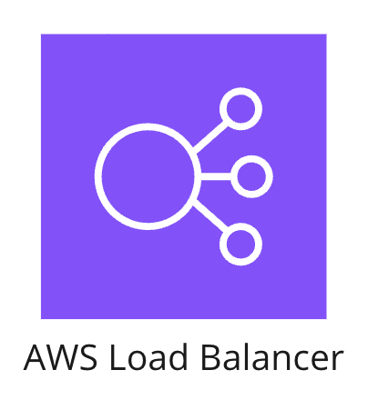

*Auto-Scaling* automatically adjusts the number of EC2 instances based on the demand. It can create new instances when demand increases and terminate them when demand decreases, ensuring that your application always has the necessary resources.



### **Containerized Deployments and Serverless Compute**

In this section, we will explore computing further, exploring containers and serverless options in AWS.

**Containerized Deployments**

What are Containers?Containers package applications and their dependencies into a single lightweight, portable unit that can run anywhere, isolating them from the underlying system.

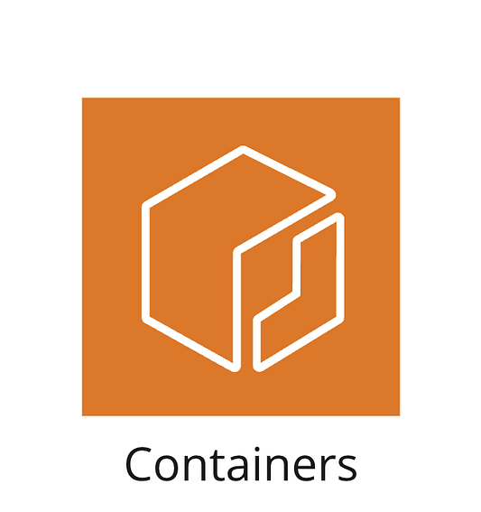

Dependencies refer to the external libraries, frameworks, tools, or services an application or system relies on to function correctly.

Why containerize? Containers offer efficient resource utilization by sharing the host OS and can be easily moved across different environments. This isolation ensures consistent performance regardless of where they are deployed.

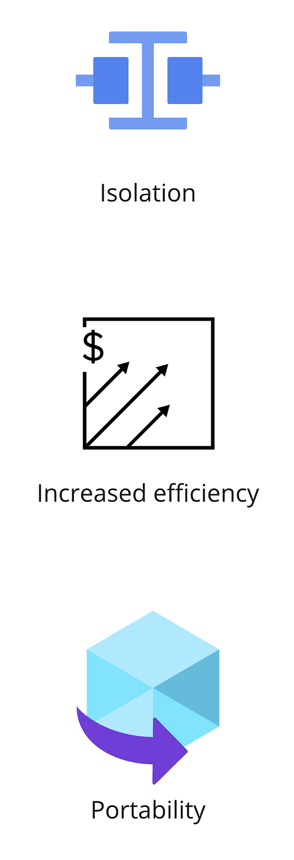Containers provide isolation, ensuring that applications run in their own environments without conflicts. They increase efficiency by sharing the host OS, reducing resource overhead. Containers also offer portability, allowing applications to move seamlessly across different environments, from development to production

**Containers in AWS**

AWS offers container deployments through Amazon Elastic Container Service (ECS) and Amazon Elastic Kubernetes Service (EKS).

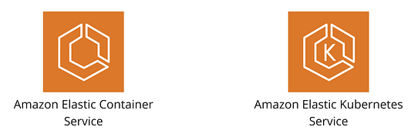

Both of these services have robust scalability allowing containerized applications to scale up or down based on demand, and integrate seamlessly with other AWS services like databases and storage.

**Amazon Elastic Container Service (ECS)**

Amazon ECS is a managed orchestration service that simplifies containerized applications' deployment, management, and scaling. It is particularly effective for microservices-based applications and excels in processing large datasets through batch processing workloads across multiple AWS services

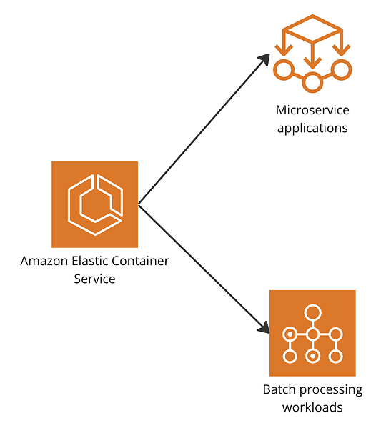Amazon Elastic Container Service (ECS) is ideal for managing microservice applications and batch processing workloads, providing a robust orchestration solution for deploying and scaling containerized applications.

**Amazon Elastic Kubernetes Service (EKS)**

Amazon EKS enhances ECS functionalities for Kubernetes-powered applications. EKS is ideal for running compute-intensive machine learning tasks and can operate in hybrid cloud environments, offering robust support for complex, scalable applications.

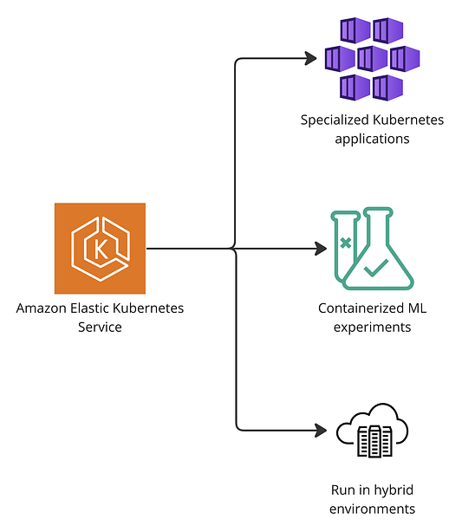mazon Elastic Kubernetes Service (EKS) is perfect for running specialized Kubernetes applications, containerized machine learning experiments, and managing workloads in hybrid cloud environments.

**Comparing Containers with Serverless Compute for Dynamic Workloads**

Containers are ideal for persistent and predictable computing needs, handling resource-intensive operations like large databases or continuous data processing efficiently. However, some specialized use-cases require more dynamic solutions. For instance, applications that only need compute resources when specific events occur or those with sporadic sessions of heavy workloads need a flexible approach. This is where serverless compute comes in as a solution. In a serverless architecture, AWS automatically manages and allocates resources only when needed, making it perfect for handling irregular, event-driven workloads without the need for manual intervention.

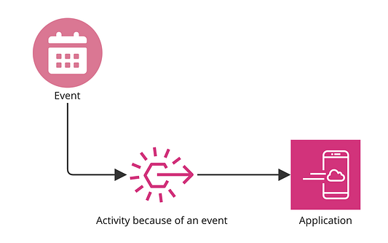**Application that triggers compute resources only when certain events occur:** Containers would not work well here, however, in serverless computing, compute resources are triggered by specific events, efficiently handling tasks only when needed.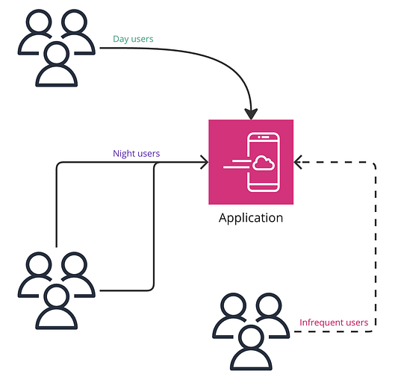**Application that has sporadic sessions of heavy workloads and would need dynamic resource allocation: Here also, containers would not be a great fit, however, in s**erverless architecture dynamically allocates resources based on varying user activity, ensuring efficient performance for day users, night users, and infrequent users without manual intervention

**Serverless Compute**

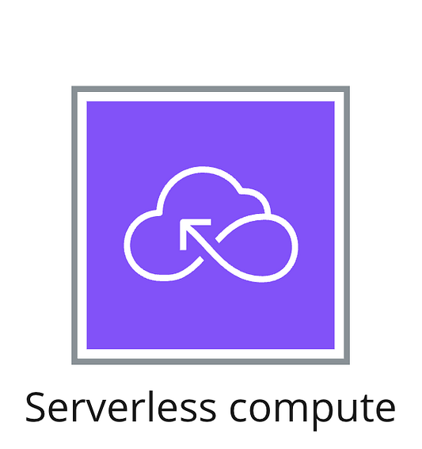

What is Serverless Architecture? In a serverless architecture, developers do not need to manage servers, they focus on writing code that is executed in response to events. AWS handles the provisioning, scaling, and maintenance of the infrastructure.

Functions inside serverless applications are triggered by events in real-time and since the usage is dynamic, you only pay for when the application is running.

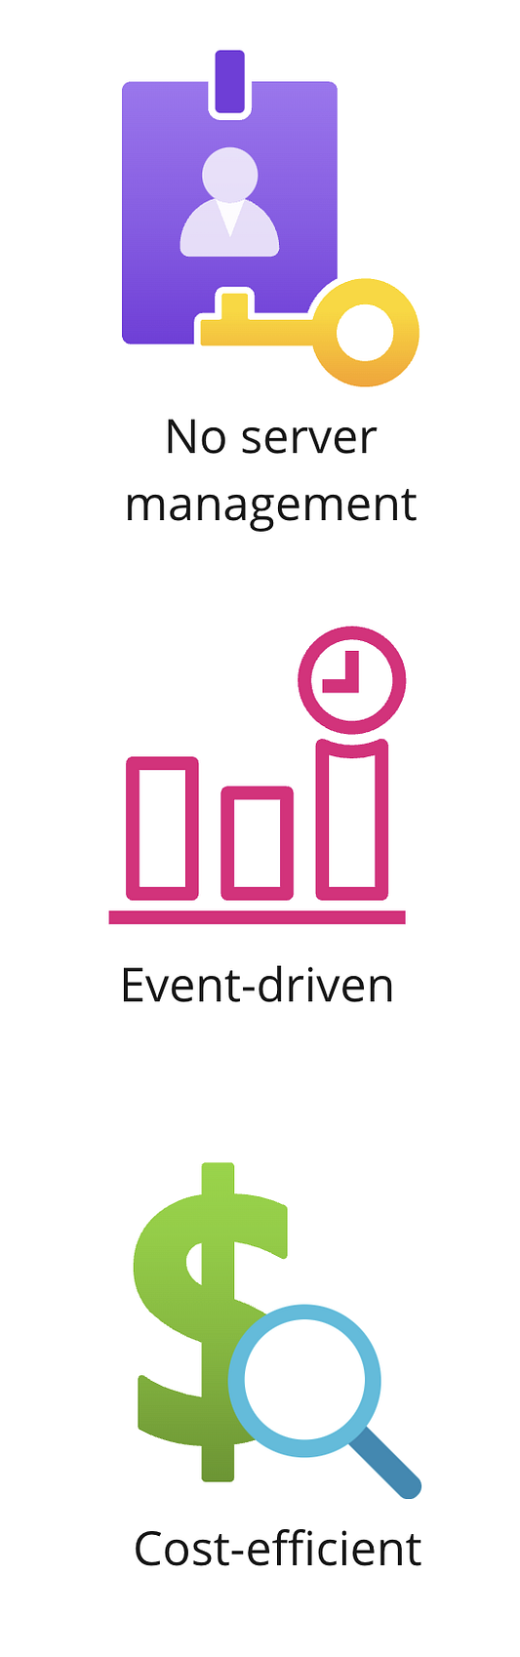

Serverless compute is ideal for scenarios where compute resources are triggered by events, applications that require real-time file processing, environments with rapidly changing compute demands due to sporadic bursts of data, and for applications like chatbots and voice assistants that handle complex data structures.

AWS offers serverless compute capabilities through **AWS Lambda** and **AWS Fargate**.

**AWS LAMBDA**

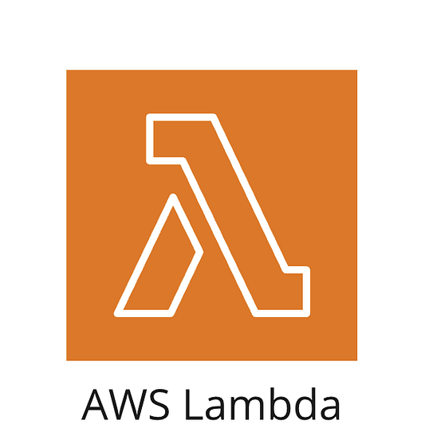

AWS Lambda is a service that automatically runs your code in response to events and scales the compute resources as needed. Here’s a simple example to illustrate how it works:

Imagine you have a photo-sharing website that requires all uploaded images to be resized to a specific dimension. Every time a user uploads a new photo, an AWS Lambda function can be triggered to resize the image.

So, when a photo is uploaded:

1. An event triggers the Lambda function.
2. The Lambda function runs a resizing algorithm on the photo.
3. The resized photo is then stored and displayed on the website.

This way, AWS Lambda automatically ensures that all photos meet the required dimensions, without any manual intervention.

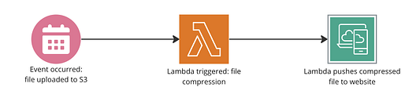When a photo is uploaded to S3, a Lambda function is triggered to resize the photo and push it to the website.

**AWS Fargate**

AWS Fargate allows you to run containers without managing servers. It’s like combining the benefits of containers and serverless computing. Fargate automatically takes care of resource allocation, making it efficient and cost-effective. It’s great for running AI and machine learning applications because it handles big data and parallel processing easily, without the need for you to manage the underlying infrastructure.

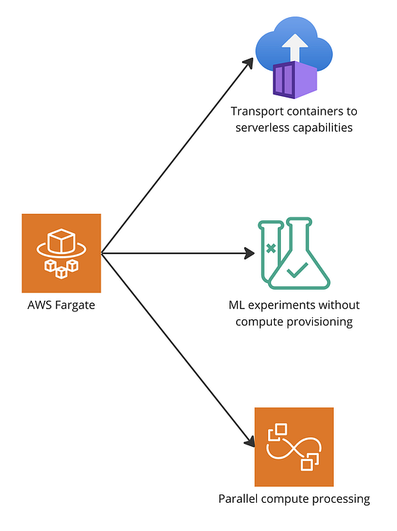AWS Fargate transports containers to serverless capabilities, allowing ML experiments without compute provisioning and enabling efficient parallel compute processing.

**Transitioning from Traditional EC2 Compute to Modern Containerized and Serverless Architectures**

Microservice architecture is a distinctive method of developing software systems that focuses on building single-function modules with well-defined interfaces and operations. Unlike microservices, a monolith application is built as a single, autonomous unit. So, any changes to the application are slow, as they affect the entire system. Microservices solve the challenges of monolithic systems by being as modular as possible. In the simplest form, they help build an application as a suite of small services, each running in its own process and being independently deployable.

Modularity refers to designing a system in separate, interchangeable components or modules. Each module or component can function independently and can be developed, tested, and deployed separately. This approach simplifies maintenance and enables scalability, as individual modules can be updated or replaced without affecting the entire system.

Amazon Elastic Compute Cloud (EC2) represents traditional compute by offering resizable virtual servers in the cloud, providing flexibility and control over computing resources. EC2 instances can be tailored for various workloads, ensuring applications have the necessary compute power.

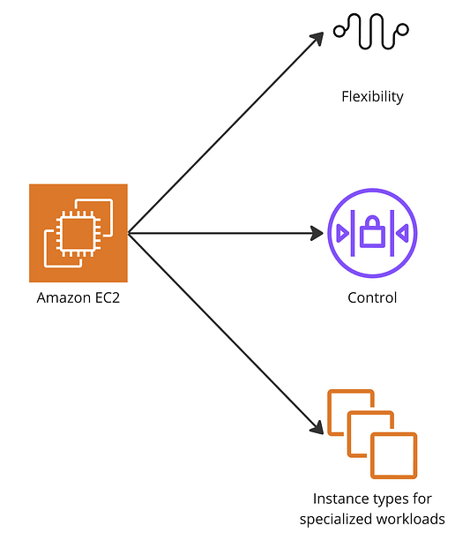Amazon EC2 provides flexibility, control, and a variety of instance types tailored for specialized workloads, representing the traditional compute model in AWS.

However, as technology evolves, there’s a shift towards more modular and efficient architectures like containerized and serverless computing. Containerized deployments, managed through services like Amazon ECS and Amazon EKS, package applications and their dependencies into portable units, enabling consistent performance across environments.

Serverless computing, exemplified by AWS Lambda and AWS Fargate, allows developers to run code and manage containers without handling the underlying infrastructure, automatically scaling based on demand and optimizing costs by charging only for actual usage.

This shift from traditional EC2 instances to containerized and serverless solutions reflects the need for more scalable, efficient, and manageable application deployment strategies in modern cloud environments.

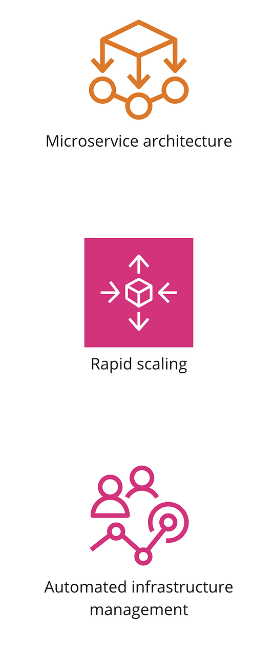Modern compute architectures in AWS focus on microservice architecture, rapid scaling, and automated infrastructure management, moving beyond traditional EC2 instances to more modular and efficient solutions like containers and

serverless computing.

*********************************************************************************************************

**Chapter 5**

### **Exploring AWS Database Resources**

Cloud databases, or Databases as a Service(DBaas), are managed database engines that allow access to databases without configuring physical infrastructure or installing software. AWS provides different types of databases for various use cases:

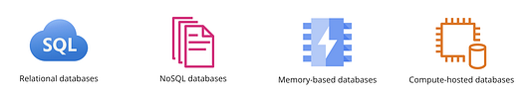Relational databases store data in structured tables and support SQL queries, making them ideal for transactional applications. NoSQL databases handle unstructured data like JSON documents, providing flexibility for evolving data models. Memory-based databases use in-memory storage for fast data retrieval, suitable for caching and real-time applications. Compute-hosted databases deploy databases on virtual machines for custom configurations and control over the environment.

**Relational Databases**

Relational databases are structures storage systems that organize data into tables, and build relationships to other tables using keys. Examples include MySQL or PostgreSQL. Relational databases offer scalability, consistency and data integrity.

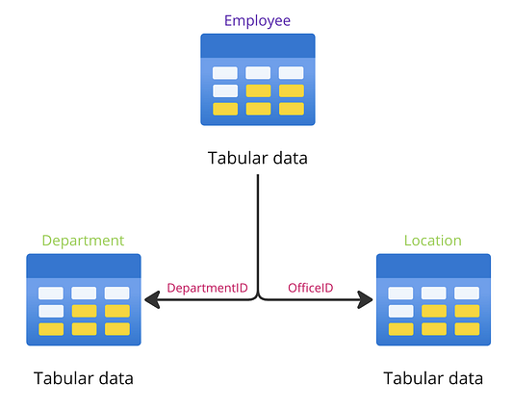This diagram illustrates a relational database with three tables: Employee, Department, and Location. Each table stores tabular data and uses unique identifiers (DepartmentID and OfficeID) to establish relationships between the tables, enabling efficient data organization and retrieval.

AWS provides relational database management through two services, Amazon RDS and Amazon Aurora.

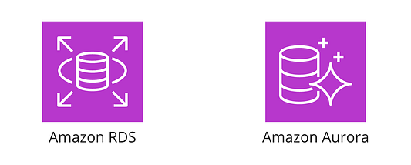RDS & Aurora

**Amazon Relational Database Service (RDS)**

RDS is a fully managed relational database that supports user setup control, operation, and scaling. Amazon RDS supports multiple database engines, including Amazon Aurora, PostgreSQL, MySQL, MariaDB, and others. A **database engine** is the core software component that a database management system (DBMS) uses to create, read, update, and delete (CRUD) data from a database. It handles the data storage, retrieval, and management tasks. RDS performs well in both cloud and on-premises environments.

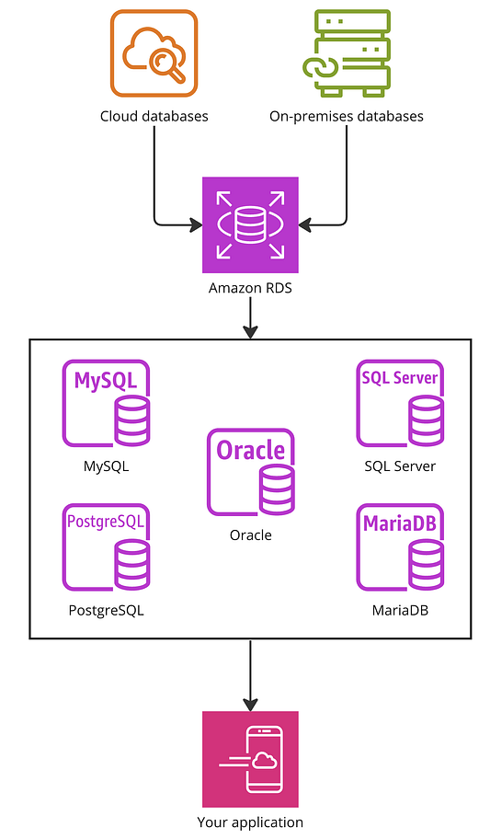Amazon Relational Database Service (RDS) supports both cloud and on-premises databases. It allows you to run various database engines such as MySQL, PostgreSQL, Oracle, SQL Server, and MariaDB. RDS handles database management tasks, letting you focus on your application.

**Amazon Aurora**

Amazon Aurora is a relational database service optimized for MySQL and PostgreSQL engines. It provides high performance at a much lower cost compared to traditional on-premises databases. Aurora automatically performs continuous backups and supports multi-region deployments, ensuring your data is always available and protected.

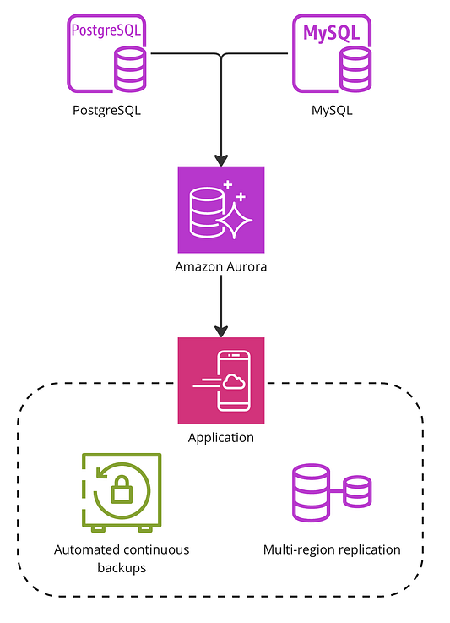Amazon Aurora, compatible with PostgreSQL and MySQL, provides high performance and cost efficiency. It features automated continuous backups and multi-region replication, ensuring high availability and reliability for your applications.

**RDS Vs. Aurora**

**Amazon RDS**:

General Purpose: Supports a wide range of database engines including MySQL, PostgreSQL, Oracle, SQL Server, and MariaDB.

**Use Case**: Suitable when you need flexibility to choose from different database engines.

**Amazon Aurora**:

**Specialized Service**: Designed specifically for MySQL and PostgreSQL.

**High Performance**: Fine-tuned for high performance and cost efficiency for MySQL and PostgreSQL databases.

**Use Case**: Ideal when you specifically need a MySQL or PostgreSQL database with optimized performance and features.

**Summary**:

Use **RDS** for a variety of database engines.

Choose **Aurora** for high-performance MySQL or PostgreSQL databases.

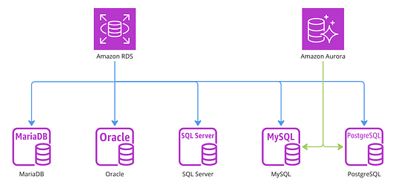Amazon RDS supports a variety of database engines including MariaDB, Oracle, SQL Server, MySQL, and PostgreSQL. Amazon Aurora specializes in MySQL and PostgreSQL, offering enhanced performance and features like automated continuous backups and multi-region replication.

**NoSQL Databases**

NoSQL databases go beyond the traditional table-based relational database model to support flexible data models like JSON and raw documents. They offer dynamic schema flexibility, allowing them to adapt to changing data structures and scale horizontally to handle increasing amounts of data. They are perfect for unstructured or semi-structured data. NoSQL databases do not use SQL as their primary query language and can store data in various formats such as documents, key-value pairs, wide-column stores, or graphs.

AWS offers two NoSQL database services, DocumentDB and DynamoDB.

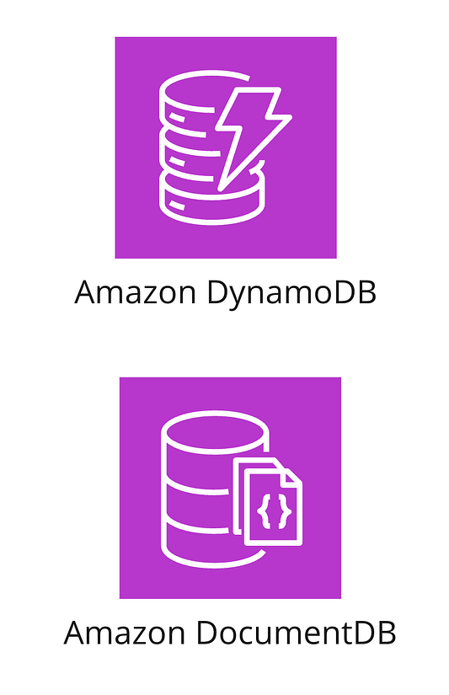

**Amazon DynamoDB**

Amazon DynamoDB is a managed NoSQL database built on a serverless architecture that provides high performance with limitless throughput and storage.

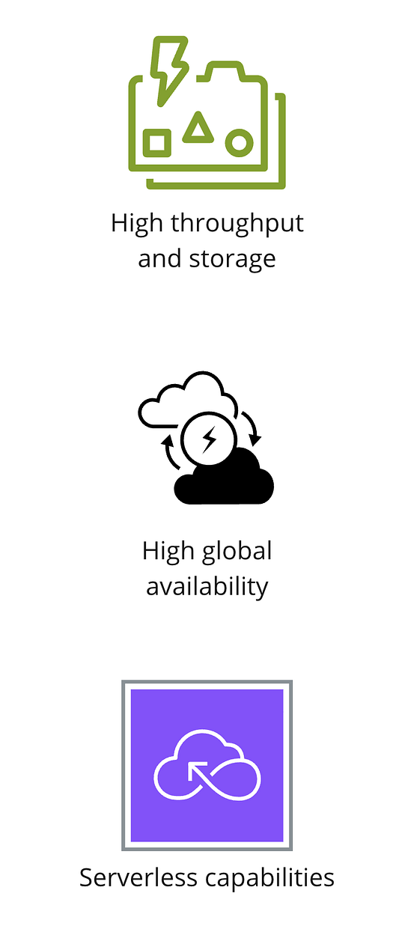

It guarantees 99.999% availability and scales seamlessly. DynamoDB handles unstructured data, such as real-time video streaming or media content. It’s also well-suited for tracking inventory, managing shopping carts for customer profiles, and maintaining session history and leaderboards on gaming platforms.

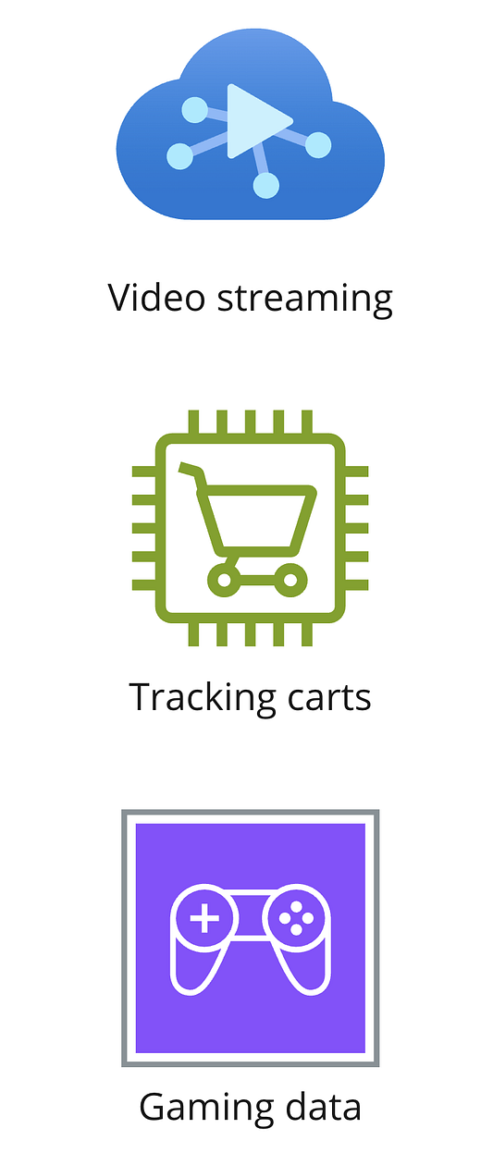

**Amazon DocumentDB**

MongoDB is a popular NoSQL database designed to store and retrieve data in JSON-like documents, making it flexible and scalable. It’s often used for handling large volumes of unstructured data.

Amazon DocumentDB is AWS’s managed NoSQL service that offers compatibility with MongoDB. It is designed for working with large-scale document workloads without the need for infrastructure management.

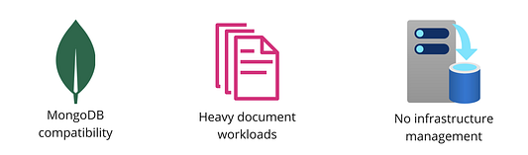

This service is commonly used in:

1. Content Management System**s:** Managing data like text reviews and images.
2. Recommendation Engines**:** Handling millions of user profiles.
3. Generative AI Use Case**s:** Managing large semantic, language-based data.

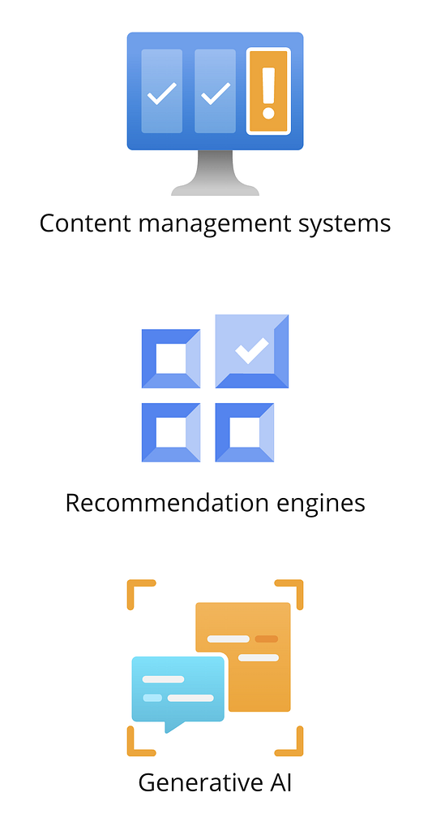

**Memory-Based Databases**

Another category of databases offered by AWS are memory-based databases. These are designed for high-performance storage and utilize RAM for super-fast retrieval. They are used in applications that require caching, need real-time data processing, or track high-throughput high-speed transactions.

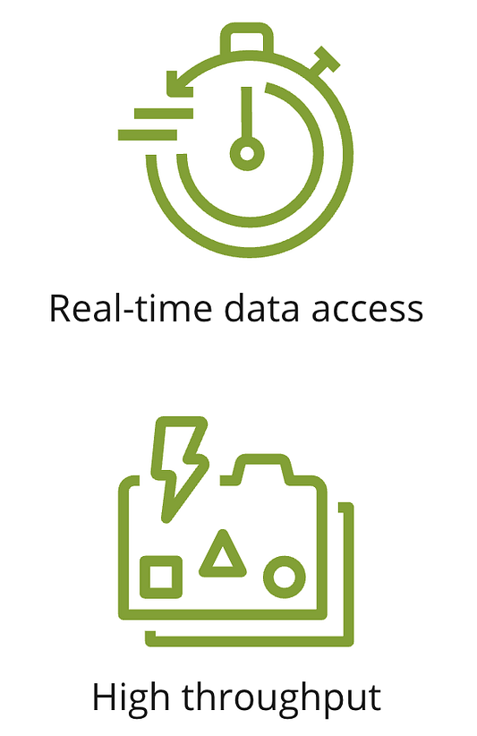

**MemoryDB for Redis**

MemoryDB for Redis is AWS’s offering for memory-based databases that gives microsecond read and millisecond write capabilities. It is hosted with 99.99% global availability and is equipped with fault tolerance to recover instantaneously from any outages or issues

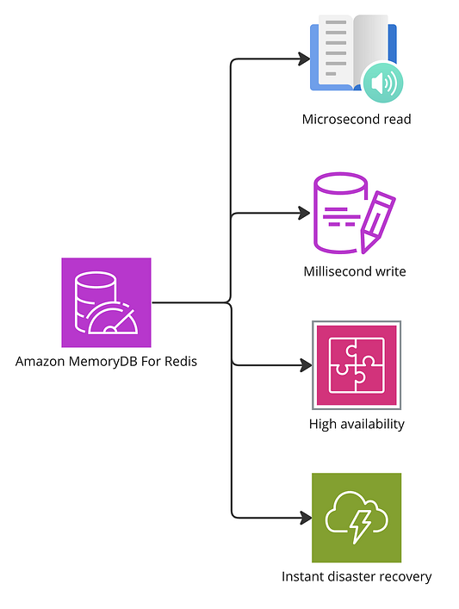Amazon MemoryDB for Redis offers microsecond read and millisecond write capabilities, providing high availability with 99.99% global uptime and instant disaster recovery for memory-based database needs.

**Compute-Hosted Databases**

EC2-hosted databases, also known as compute-hosted databases, are custom databases deployed on Amazon EC2 instances. They simplify data access during compute tasks and offer granular control over configuration and management. However, users are responsible for backups.

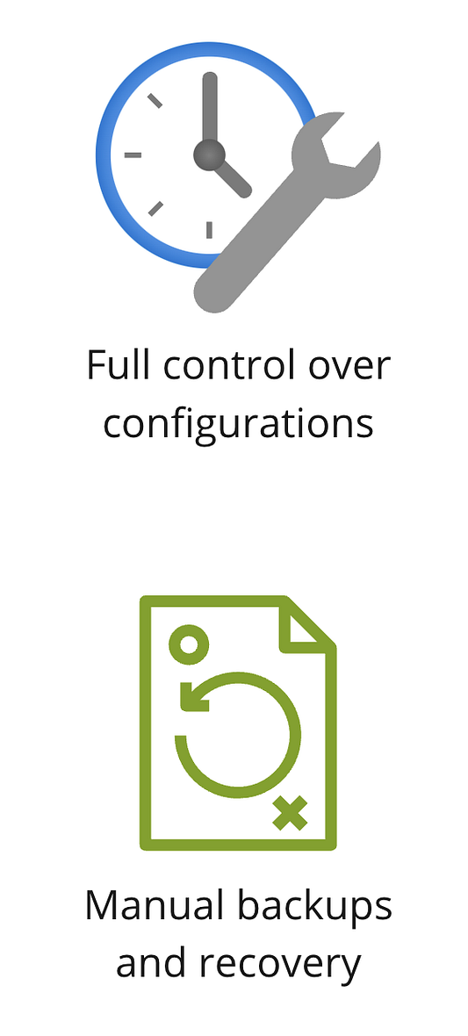

They are deployed on EC2 instances following a traditional, manual approach to database hosting.

**Compute databases vs static databases**

When deciding between EC2-hosted and AWS-managed databases (static), consider the level of control and automation you need. Choose EC2-hosted databases for full control over configuration, but opt for AWS-managed databases if you prefer an automated, fully managed service.

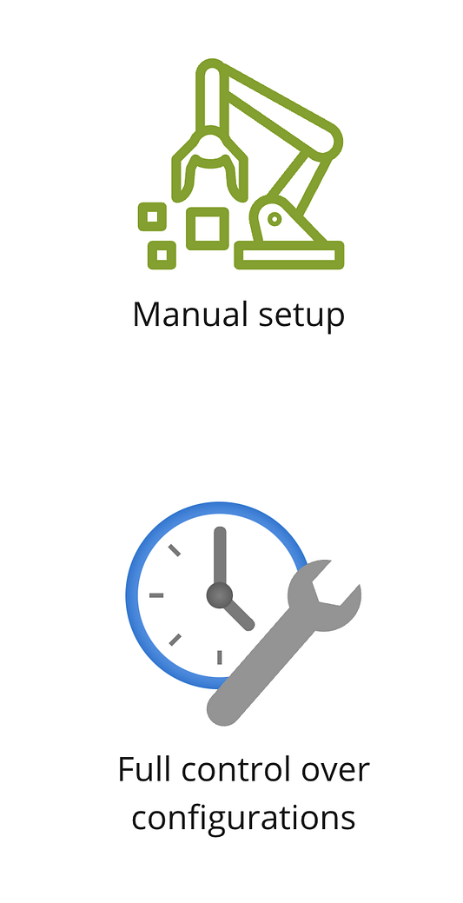For applications where you need full control over database configuration choose EC2-hosted databases.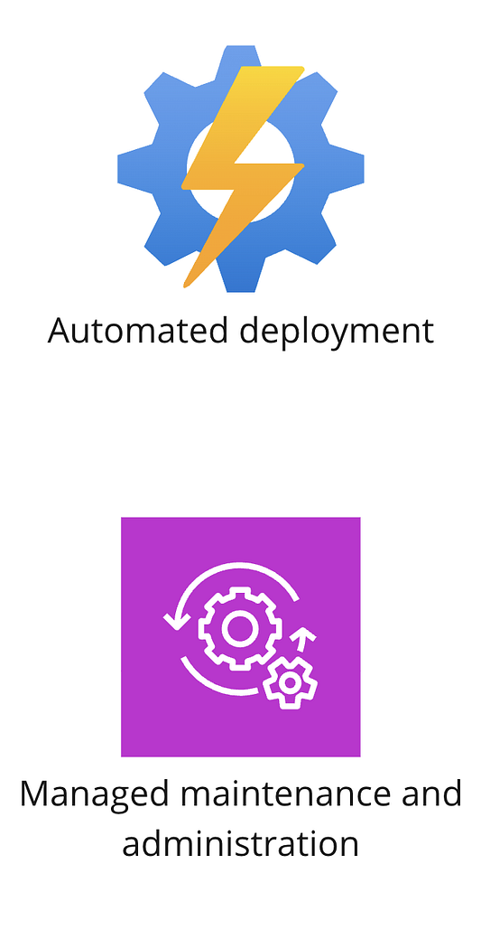If you are looking for an automated and fully managed service then AWS-managed databases are the way to go  
  
*********************************************************************************************************

**Chapter 6**

### **Database Migration Services in AWS**

When we talk about storing data in the cloud, an important question arises: how does data get into the cloud in the first place? This is where database migration comes in. AWS provides robust tools and services to facilitate the smooth transfer of data from on-premises databases to cloud-based solutions, ensuring minimal downtime and seamless integration.

Database migration is moving all your data from one environment to a brand new environment.

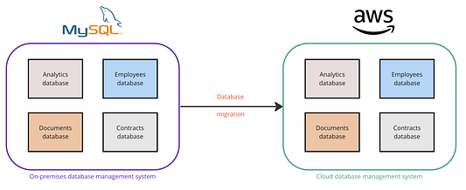Moving data from on-premise to cloud.

**Why Do We Need Data Migration?**

Legacy systems are outdated computer systems, software, or technologies. Legacy systems often struggle to meet the current demands for scalability, efficiency, and integration with newer technologies and applications.

Data migration is essential because legacy systems often fail to meet today’s rapidly evolving scalability and efficiency requirements. Modern applications, such as those using generative AI, demand advanced compute and storage capabilities. Furthermore, businesses now gather data from numerous sources, necessitating a unified management layer. Migrating data to advanced environments helps achieve these goals, ensuring that businesses can efficiently manage and leverage their data in a centralized, robust platform.

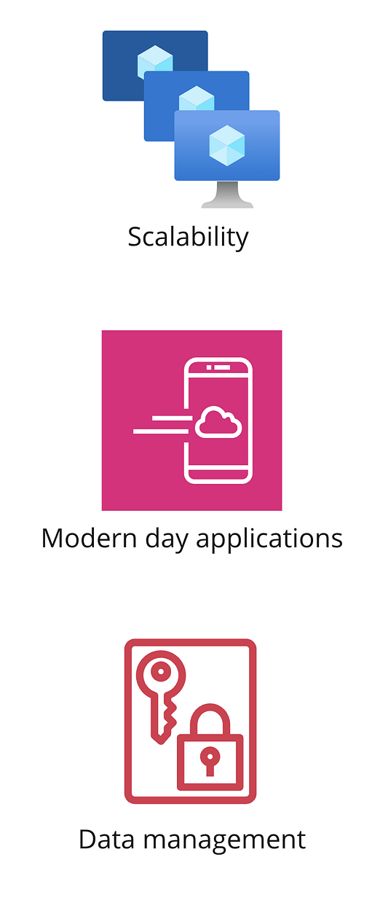Data migration is essential to meet modern scalability demands, enable support for advanced applications, and ensure efficient data management across diverse sources.

**Data Migration in Practice**

A typical data migration project consists of five steps. First, an assessment of existing data structures, formats, and dependencies of the source data. Second, preparation, where a clear migration plan is developed and source data is organized. Third, execution, where necessary tools and operations are deployed to perform the migration without inconsistencies. Fourth, validation to verify data integrity post-migration and conduct thorough testing. Finally, optimization, to fine-tune the performance of applications in the new environment.

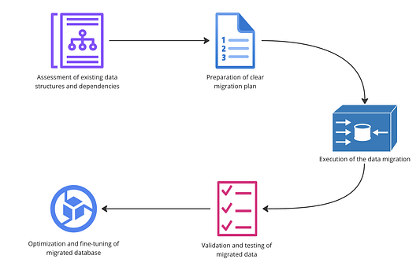A typical data migration project involves five key steps: assessing existing data structures and dependencies, preparing a clear migration plan, executing the data migration, validating and testing the migrated data, and optimizing and fine-tuning the migrated database for performance in the new environment.

Aws offers four services to support database migration, the Database Migration Service, AWS Snow Family, DataSync, and the Schema Conversion Tool.

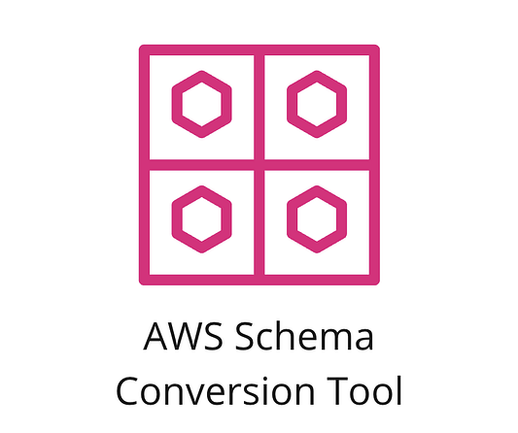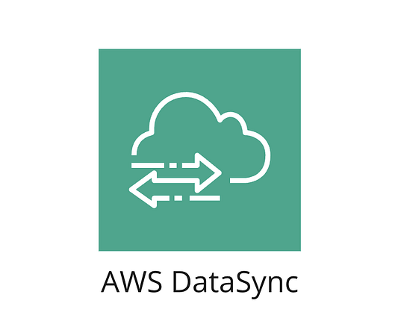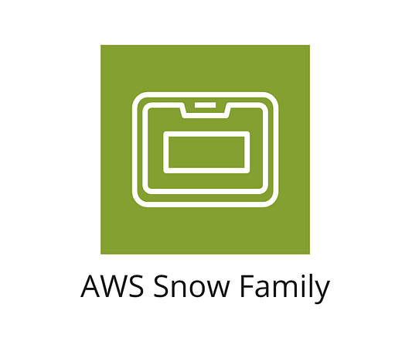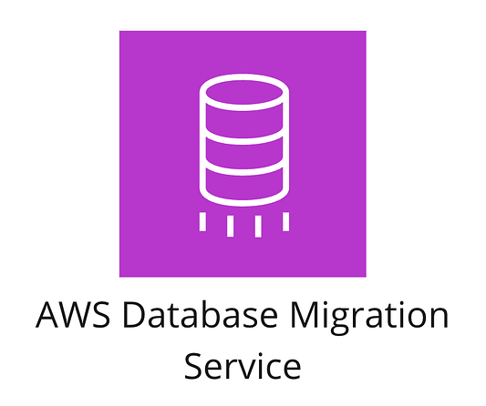

**Amazon Database Migration Service (DMS)**

Database Migration Service (DMS) is a tool that facilitates the seamless transfer of databases and analytics engines to AWS. It operates by replicating data across multiple availability zones, which ensures minimal downtime during the migration process. DMS supports various source and target databases, making it versatile for different migration needs. Additionally, it includes validation checks and task monitoring features to maintain data integrity throughout and after the migration.

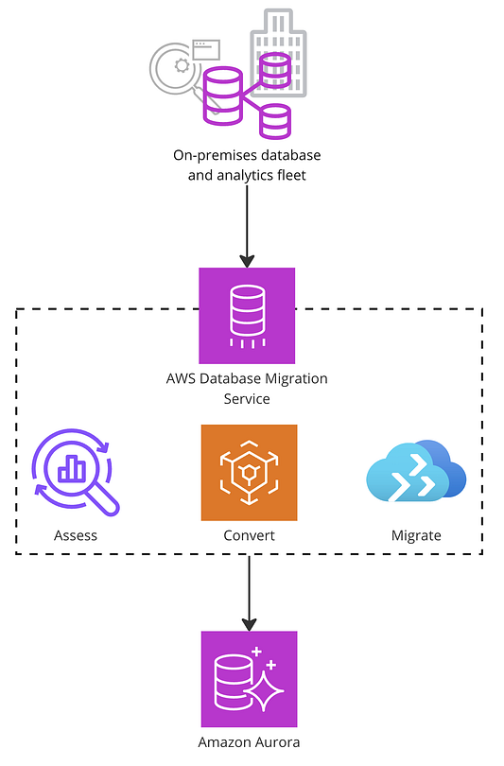

The image above illustrates the process of migrating an on-premises database and analytics fleet to Amazon Aurora using AWS Database Migration Service (DMS). The steps involved in this process are:

1. **Assess**: Evaluating the existing database to understand its structure, dependencies, and requirements.
2. **Convert**: Using the AWS Schema Conversion Tool to transform the database schema and code to be compatible with Amazon Aurora.
3. **Migrate**: Moving the data from the on-premises database to Amazon Aurora, ensuring minimal downtime and data integrity.

AWS DMS facilitates this process by replicating data across multiple availability zones, ensuring high availability and reliability during the migration. The end result is a database hosted on Amazon Aurora, benefiting from its high performance and managed service capabilities.

**AWS Snow Family**

The AWS Snow Family consists of physical devices that help move very large amounts of data (petabytes) offline. These devices are used in remote locations or places close to where the data is stored. They have strong security features like encryption and seals that show if someone tried to tamper with the device, ensuring the data remains safe.

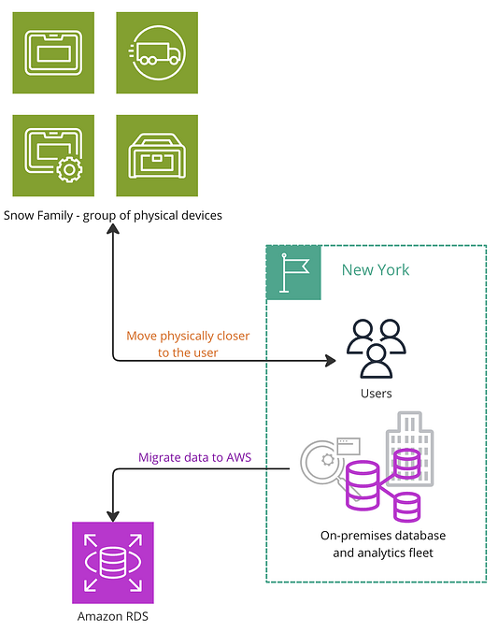The AWS Snow Family consists of physical devices designed for offline migration of large-scale data. These devices are moved physically closer to the data source, such as users in New York, to facilitate efficient data transfer. After collecting the data, it is migrated to Amazon RDS in the AWS cloud for further processing and storage. This approach ensures data integrity through robust security measures and helps streamline the migration process for on-premises databases and analytics fleets.

**AWS DataSync**

AWS DataSync is a service that helps transfer large amounts of data from your local storage to the cloud quickly and efficiently. It uses parallel processing to speed up the transfer and integrates smoothly with AWS storage services like S3. DataSync can be automated using the AWS management console or APIs, making the process even easier.

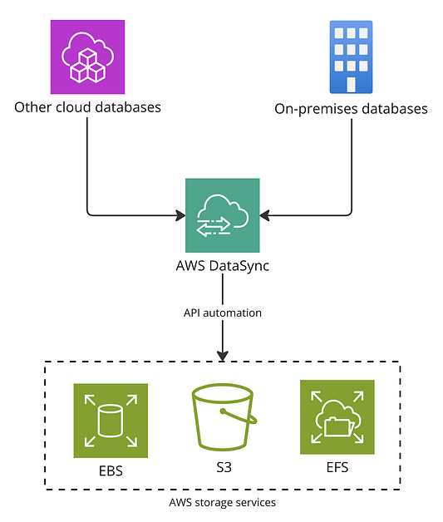AWS DataSync efficiently transfers large volumes of data from on-premises databases and other cloud databases to AWS storage services like EBS, S3, and EFS. It utilizes API automation for seamless integration and parallel processing capabilities to ensure fast and effective data transfer. This helps in synchronizing data across various environments, providing a robust solution for managing extensive data migration tasks.

**AWS Schema Conversion Tool**

The AWS Schema Conversion Tool automates the conversion of database schemas from one format to another. It maps objects from the source database to the target database, reducing the need for manual work. This tool also allows for custom conversion rules, checks the converted schema for errors before migration, and provides live feedback to address any issues that arise during the process.

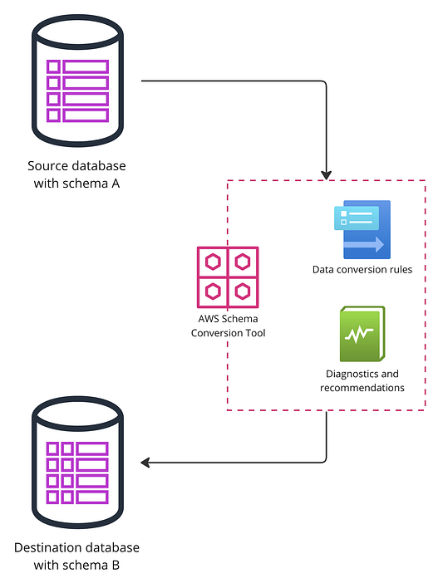The AWS Schema Conversion Tool simplifies the process of migrating databases by automatically converting database schemas from the source database (schema A) to the destination database (schema B). It applies data conversion rules, validates the schema, and provides diagnostics and recommendations to ensure a smooth and efficient migration.

**When to use which service?**

We have four AWS database migration services, each best suited for specific scenarios:

1. **Database Migration Service**: Best for large-scale and complex data migrations across different types of databases.
2. **AWS Snow Family**: Ideal for large physical data volumes, limited internet bandwidth, or when data needs to be processed locally before moving to AWS.
3. **AWS DataSync**: Perfect for frequent and automated large-scale data transfers between on-premises storage and AWS.
4. **AWS Schema Conversion Tool**: Useful when migrating databases with different structures, helping to reduce manual work and ensure a smooth transition.

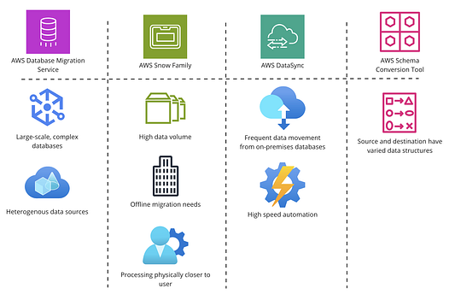AWS offers Database Migration Service for complex, large-scale migrations, Snow Family for high data volumes and offline needs, DataSync for frequent, automated data transfers, and Schema Conversion Tool for varied data structure migrations.  
  
*********************************************************************************************************

**Chapter 7**

### **AWS Networking & Content Delivery**

This section highlights how AWS supports the connectivity of cloud resources, allowing them to effectively communicate across far-flung locations. It also delves into how AWS networking services ensure secure and reliable connections and content delivery. It covers five crucial services: Amazon VPC (for creating private networks within AWS), Amazon VPN (for secure connections to AWS), AWS Direct Connect (for dedicated network connections to AWS), Amazon Route 53 (for domain name services), and Amazon CloudFront (for distributed content delivery).

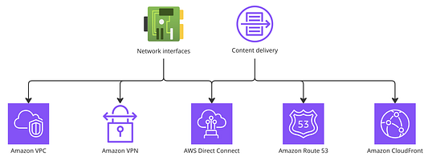Overview of Key AWS Networking Services: This diagram illustrates the integration and functionality of Amazon VPC, Amazon VPN, AWS Direct Connect, Amazon Route 53, and Amazon CloudFront. These services collectively enhance network interfaces and content delivery, securing and optimizing cloud-based communications and data exchange.

**Amazon Virtual Private Cloud (VPC)**

Amazon VPC establishes networking in AWS by providing a private, logically isolated space in the global AWS infrastructure for defining and launching resources. VPCs are regionally hosted, residing in one AWS region.

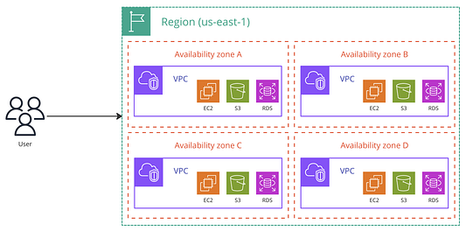Regional Distribution of AWS Resources: This diagram showcases how Amazon VPCs operate within a single AWS region, divided across multiple availability zones. Each zone can host various AWS services like EC2, S3, and RDS, providing robust, scalable, and isolated environments for deploying applications and storing data

Amazon VPC allows for a dedicated network environment within the AWS cloud that supports both IPv4 and IPv6 protocols, and allows users to customize IP address ranges according to their specific needs.

**Building a Logically Isolated Virtual Network:**

1. **Security Layers:** Amazon VPC enhances security through the use of security groups and network access control lists (ACLs), which act as firewalls to control traffic at the instance and subnet level, respectively.
2. **Control Over Network Components:** It provides extensive control over network configuration by allowing the creation and customization of subnets, route tables, and network gateways. This flexibility helps in designing a network that closely fits an organization’s IT infrastructure needs.

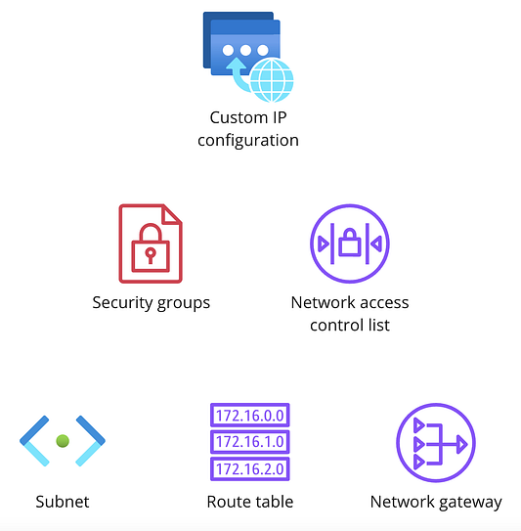Key Components of Amazon VPC: This diagram highlights the fundamental elements of Amazon Virtual Private Cloud (VPC), showcasing custom IP configuration, security measures with security groups and ACLs (Access Control Lists), and network structuring tools like subnets, route tables, and gateways. Each component plays a critical role in creating a secure, isolated, and efficient virtual network within AWS.

Let’s delve deeper into these essential features to understand how they bolster network isolation and security within the Amazon VPC.

**Key VPC concepts**

**Custom configurable IP address range**

IP addresses act as your designated spaces in the digital realm, much like having a specific office address in the physical world. Amazon VPC (Virtual Private Cloud) allows you to set up this virtual address space within the AWS ecosystem according to your specific requirements.

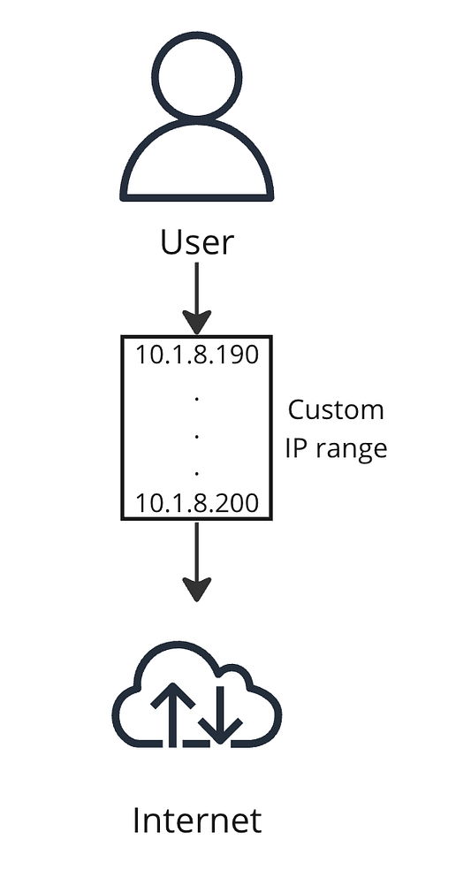User Defined IP Address Range: This diagram illustrates how a user in an Amazon VPC can specify a custom IP address range, in this example from 10.1.8.190 to 10.1.8.200, to securely connect to the internet. It showcases the allocation of virtual addresses that allow for controlled and secure internet communication.

Subnets (sub networks), or subdivisions of your VPC divide your VPC IP adress range into smaller, maneageable segments, they function similarly to breaking down a large office into smaller, more manageable departments, each with its own designated roles and responsibilities, yet all operating under the same organizational address. This division helps in organizing, managing, and securing the network’s resources efficiently.

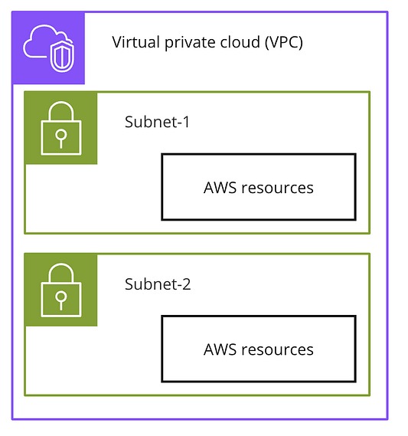Structure of a Virtual Private Cloud (VPC): This diagram depicts a Virtual Private Cloud (VPC) divided into two subnets, each containing secured AWS resources. This segmentation allows for tailored security settings and resource management within a protected, isolated network environment.

**Route tables**

Route tables in a Virtual Private Cloud (VPC) contain rules that determine the pathways for network traffic, either from your subnets or through gateways, directing how data moves within the VPC or to external networks.

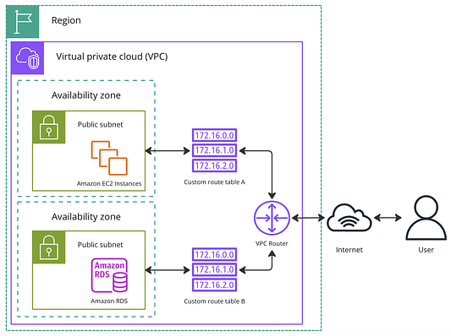This diagram illustrates how traffic is managed within a Virtual Private Cloud (VPC) across different availability zones. It shows two public subnets, one hosting Amazon EC2 instances and the other Amazon RDS databases, each governed by their own custom route tables. The VPC router directs traffic between these subnets, the internet, and end-users, highlighting the seamless integration of networking resources within a single AWS region.

Network gateways, on the other hand, are key components that manage connections between your VPC and the wider internet, or between different VPCs. They handle both incoming and outgoing traffic, ensuring that data exchanges are secure and efficient.

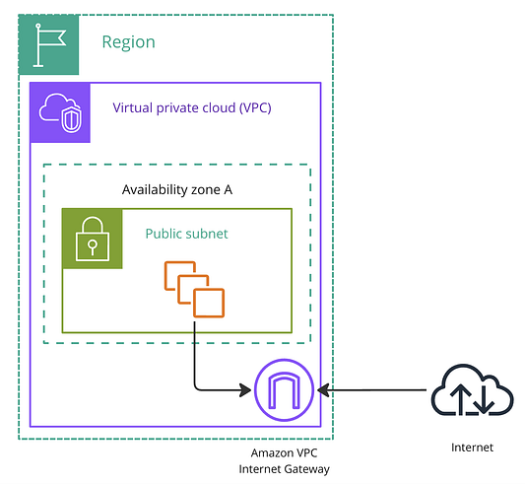Connecting to the Internet from an AWS VPC: This diagram demonstrates how resources within a public subnet of a Virtual Private Cloud (VPC) in Availability Zone A are connected to the internet through the Amazon VPC Internet Gateway. The setup ensures secure and controlled access to and from the internet for services running within the VPC.

**Default vs. custom Amazon VPC**

Virtual Private Clouds (VPCs) in AWS are available in two types, each serving different levels of user needs and customization:

**Default VPCs**: Automatically created for every new AWS account, default VPCs are pre-configured to simplify initial setup. They come with a subnet in every availability zone within the region tied to the account, allowing resources placed within them to communicate with the internet right out of the box.

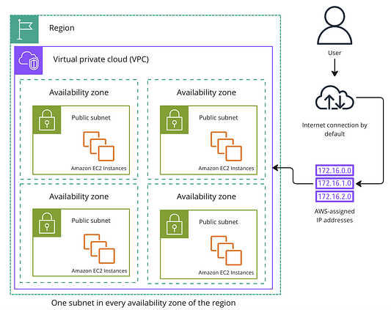Layout of a Default VPC Across Multiple Availability Zones: This diagram visualizes a default Virtual Private Cloud (VPC) setup within AWS, showing one public subnet in each availability zone of a region. Each subnet hosts Amazon EC2 instances and is configured with AWS-assigned IP addresses, ensuring internet connectivity by default for ease of use and immediate accessibility.

**Custom VPCs**: For users needing specific configurations, custom VPCs provide the flexibility to define and customize network settings according to precise requirements. These include choosing custom IP address ranges, setting up specific route tables, and more. Internet access for custom VPCs isn’t automatic; it requires explicit configuration, giving users more control over their network security and traffic management.

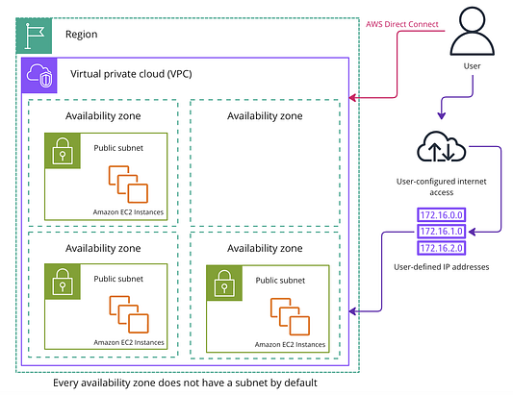Custom VPC Configuration Across Availability Zones: This diagram illustrates a custom Virtual Private Cloud (VPC) within AWS, where public subnets in selected availability zones host Amazon EC2 instances. Not every zone contains a subnet, showcasing the flexibility in custom VPC setups. Additionally, user-defined IP addresses and user-configured internet access via AWS Direct Connect are highlighted, emphasizing the enhanced control and connectivity options available to users.

**Network Security**

Network security is crucial in establishing robust and secure networking within cloud environments. AWS enhances the security of its networks by managing both inbound and outbound traffic, which are essential for regulating data entering and leaving the network.

1. **Inbound Traffic:** Refers to external data packets that are received by a network. In the context of AWS, it typically means any requests or data sent to your resources in the cloud from other networks, including the internet.
2. **Outbound Traffic:** Involves data packets that are sent from your network to an external network. This could include responses from your applications hosted on AWS to users or other external systems.

To ensure the security of these traffic flows, AWS provides two key services:

**Network Access Control Lists (ACLs):** These act as a virtual firewall at the subnet level within an AWS VPC. Network ACLs are stateless; they evaluate the incoming and outgoing packets separately and control traffic to and from subnets based on specified rules, such as allowed IP ranges, protocols, or ports. This means each packet is inspected independently, without considering any previous packets.

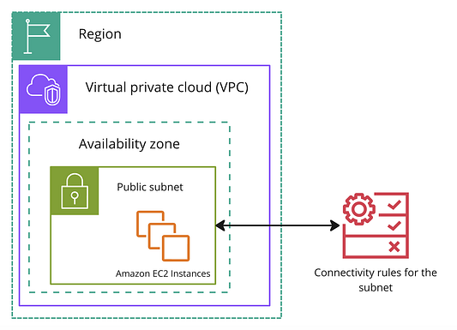NACL Configuration in a VPC: This diagram showcases the Network Access Control List (NACL) which acts as a firewall for the public subnet in an AWS VPC. It outlines the connectivity rules for the subnet, managing both inbound and outbound traffic to enhance network security.

**Network Security Groups (NSGs):** These provide a similar function but are associated directly with AWS services, such as EC2 instances. Unlike Network ACLs, Security Groups are stateful, meaning they automatically allow return traffic to flow out regardless of outbound rules, as long as the traffic matches the inbound rules.

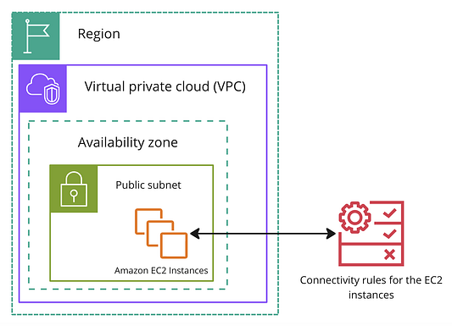Security Group for EC2 Instances: This image depicts the Security Group settings for Amazon EC2 instances within a public subnet of a VPC. The Security Group controls the flow of traffic to and from the EC2 instances, providing a critical layer of security by specifying allowed and blocked traffic.

**VPC endpoints**

Beyond security, resource communication is important for networking. VPC endpoints enable private, secure connections between AWS services without public IP addresses.

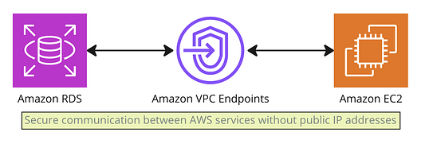

**AWS PrivateLink**

AWS PrivateLink is a specialized type of VPC endpoint that facilitates private connections between different Virtual Private Clouds (VPCs), various AWS services, and on-premises networks without requiring exposure to the public internet. This service simplifies network management by reducing the need for complex firewall rules and network configurations, thereby enhancing security and streamlining the secure exchange of data across different environments.

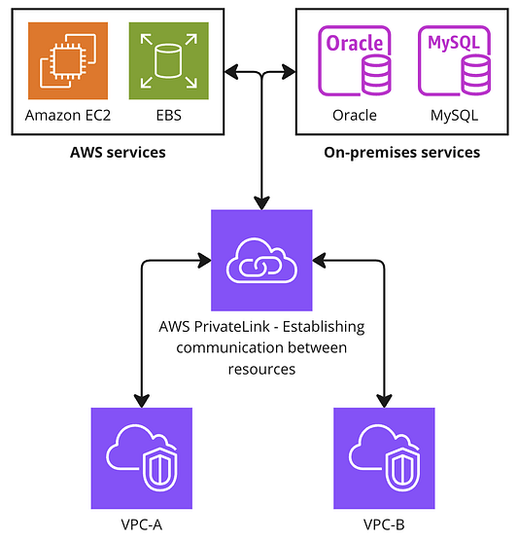This diagram illustrates how AWS PrivateLink facilitates secure, private connections across different environments. It shows AWS services like Amazon EC2 and EBS connecting securely to on-premises databases such as Oracle and MySQL, as well as enabling communication between multiple VPCs (VPC-A and VPC-B), ensuring data remains within the AWS network to enhance security and reduce latency.

Two other ways of connecting to AWS that we have previously seen are:

1. **AWS VPN**: This service enables secure connections between an on-premises network and AWS over the internet. It’s particularly useful for smaller or temporary projects where quick setup and cost-effectiveness are priorities. AWS VPN uses standard encryption techniques to ensure that data transmitted over the internet is secure, making it a viable option for businesses that need a reliable but flexible connection.

This image illustrates how the AWS Client VPN facilitates secure internet-based connections from a customer network to the AWS Cloud. The VPN establishes encrypted connections through the customer’s firewall to AWS, ensuring secure communication over the internet and enabling access to resources within an AWS Region and its Availability Zones.

1. **AWS Direct Connect**: Described in detail from 03:07 to 03:15 in the video, AWS Direct Connect provides a more robust solution by offering a dedicated network connection between your on-premises infrastructure and AWS. This connection is direct and does not traverse the public internet, thereby enhancing security and reliability. AWS Direct Connect is ideal for high-bandwidth or mission-critical workloads, as it facilitates consistent network performance and lower latency compared to internet-based connections.

AWS Direct Connect Configuration: This diagram shows how AWS Direct Connect provides a dedicated and secure network connection from a customer’s on-premises network directly to the AWS Cloud. Bypassing the public internet through a customer firewall, it offers enhanced security and lower latency, directly linking the customer’s infrastructure to AWS services within a specific Region and Availability Zones.

**DNS — Internet’s address book**

DNS, short for Domain Name System, functions like the internet’s address book. It translates easy-to-remember domain names (like [www.example.com](http://www.example.com)) into IP addresses (like 192.0.2.1) that computers use to identify each other on the network. This system is crucial for helping users access websites using familiar names instead of complex numeric addresses.

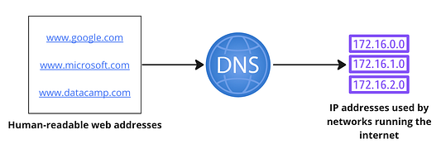

**Amazon Route 53**

Amazon Route 53 is AWS’s DNS service that translates domain names into IP addresses. It also manages domain registration and traffic routing for web applications. It ensures that user requests are efficiently routed to the appropriate servers, even distributing traffic across multiple resources to improve load times and increase fault tolerance. It’s widely used for hosting web applications and distributing incoming traffic across resources.

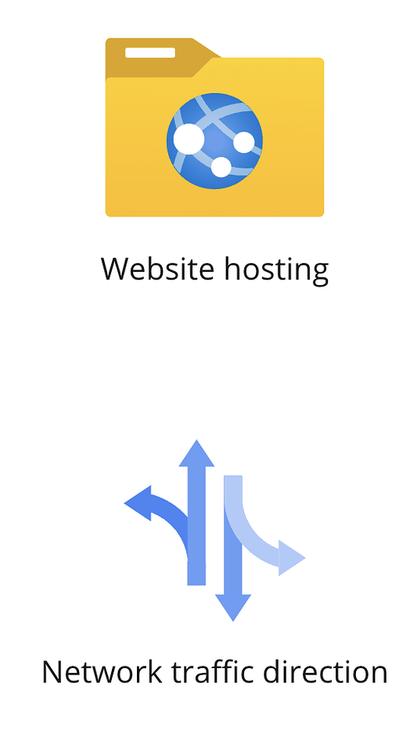

**Information movement in the cloud**

Moving information across the cloud can be slow and challenging due to distance-related delays (geographical latency) and limited bandwidth, especially when transferring data across continents.

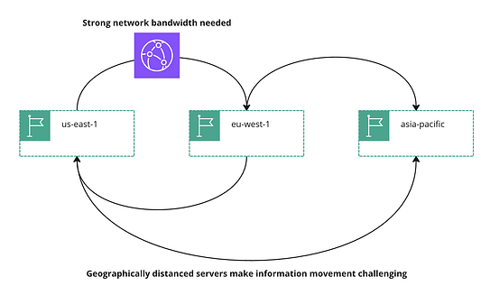Global Content Delivery Challenges: This diagram highlights the need for strong network bandwidth due to the challenges posed by geographically distant servers across multiple AWS regions — us-east-1, eu-west-1, and asia-pacific. It underscores the necessity of robust solutions to facilitate fast and reliable information movement.

**Content Delivery Networks (CDNs):** AWS addresses these challenges through CDNs, strategically placing servers worldwide to cache content closer to users. This setup speeds up data delivery, including web pages and multimedia content, by reducing the distance information needs to travel.

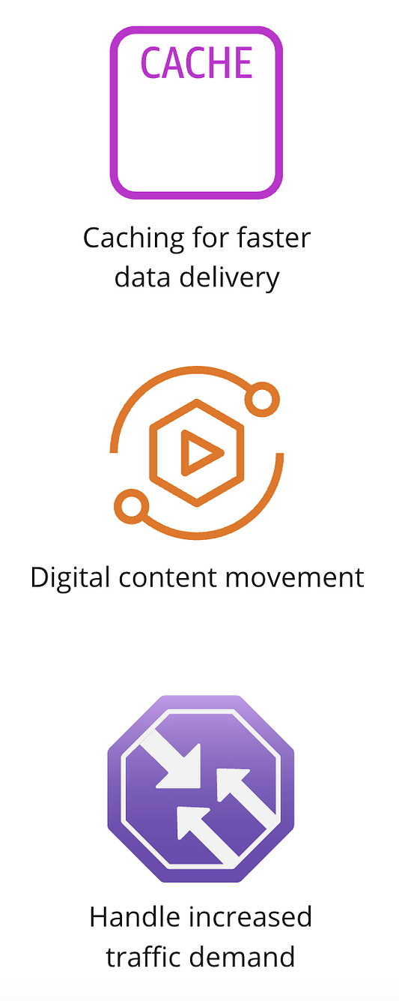Advantages of Content Delivery Networks.

**Amazon CloudFront**

Amazon CloudFront is AWS’s own CDN. It excels at quickly distributing content by leveraging a global network of servers. It efficiently handles sudden traffic spikes and scales as needed, ensuring content is delivered rapidly and reliably. It also accelerates web content, APIs, and streaming. Additionally, CloudFront enhances security by providing DDoS protection and HTTPS support, which helps secure the data transmitted between users and the network.

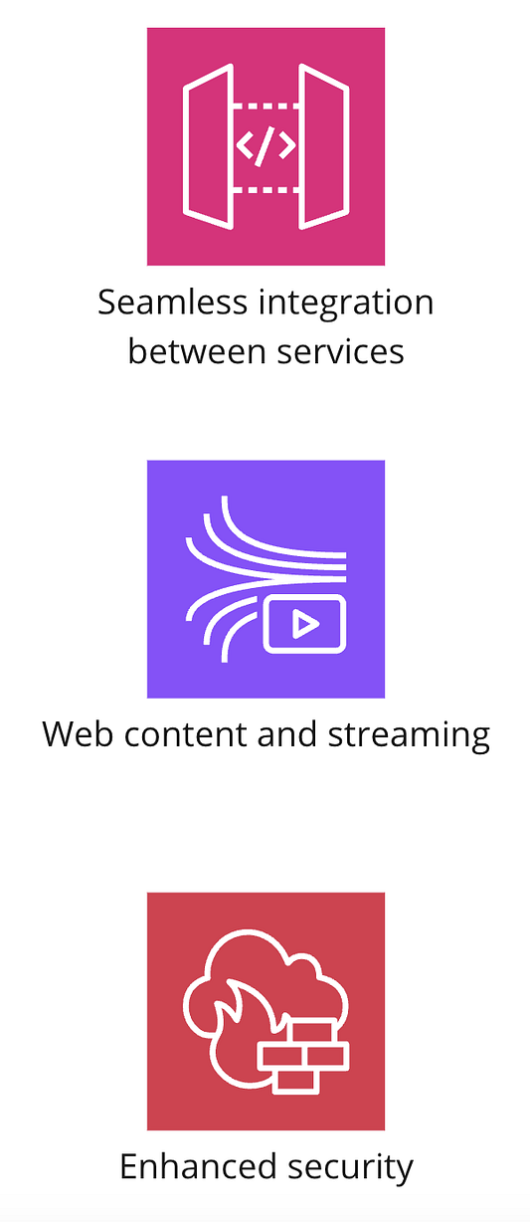Key features of AWS CloudFront: Seamless integration between services, accelerated web content and streaming, and enhanced security features like DDoS protection. These attributes collectively enhance user experience and safeguard content delivery processes

**How CloudFront is used**

Amazon CloudFront is a content delivery network that enhances user interactions with websites by speeding up the delivery of website content, leading to an improved user experience. Here’s how CloudFront is utilized effectively:

1. **Optimizing Streaming:** CloudFront minimizes buffering times during streaming, ensuring viewers can watch videos smoothly without interruption. This is crucial for maintaining engagement and satisfaction with media-heavy content.
2. **Scalable Updates:** CloudFront also excels in delivering patches and over-the-air updates to devices efficiently. It automatically scales its resources to handle these distributions, ensuring that updates are delivered promptly without overloading the system, regardless of the number of users or devices being updated simultaneously.

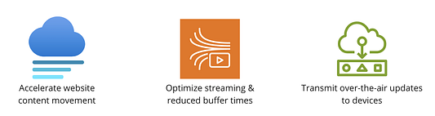

Through these features, CloudFront provides a robust platform for fast content delivery and effective digital media streaming, while also managing large-scale updates efficiently.  
  
*********************************************************************************************************

**Chapter 8**

### **AWS AI & ML Services and Machine Learning Process**

AWS is at the forefront of providing advanced AI and ML services, which are transforming how we interact with technology by automating complex processes and enabling intelligent decision-making.

**What is AI and ML?**

**Artificial Intelligence (AI)**: AI involves creating machines that can perform tasks that typically require human intelligence. This includes capabilities like problem-solving, speech recognition, and adaptive learning.

**Machine Learning (ML)**: ML is a specific branch of AI focused on developing systems that learn and improve from experience without being explicitly programmed. It uses algorithms to parse data, learn from that data, and make informed decisions based on what it has learned.

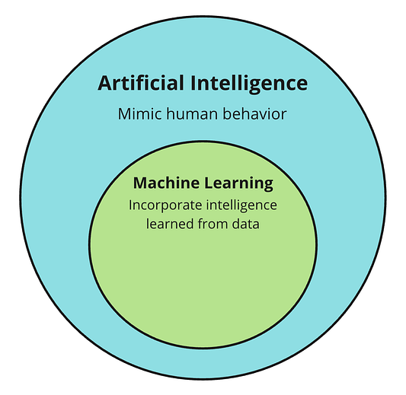

**AWS AI and ML offerings**

AWS offers a comprehensive range of AI and ML services designed to cater to various needs:

**AI Services**: These are pre-built tools for common AI tasks, such as language translation, voice recognition, and visual understanding, which can be easily integrated into applications.



**ML Services**: AWS provides services that help developers and data scientists build, train, and deploy ML models quickly.



**ML Frameworks and Infrastructure**: AWS supports all major ML frameworks like TensorFlow and PyTorch, offering flexible and scalable computing resources for training and inference.

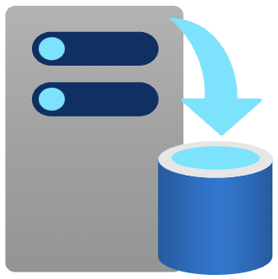

**Machine Learning Workflow**: AWS streamlines the ML workflow, from data preprocessing and model training to deployment and management, making it more accessible for users to implement ML solutions.



**AWS AI services**

AWS AI services AWS provides a suite of AI-focused services designed to simplify the implementation of artificial intelligence into various applications without the need for deep machine learning expertise. These services use pre-trained or auto-trained models that allow developers to integrate advanced AI capabilities quickly and efficiently. This simplicity encourages individuals interested in AI to explore and implement these services with confidence.

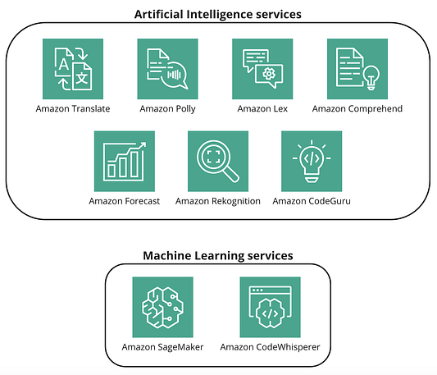

Here’s an overview of some prominent AWS AI services:

1. **Amazon Rekognition**:

This service provides powerful image and video analysis capabilities. It can identify objects, people, text, scenes, and activities in images and videos, and it also offers facial recognition technology.

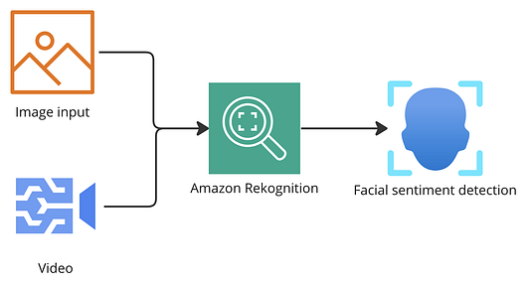

1. **Amazon Polly**:

Converts test into lifelike, natural-sounding speech.

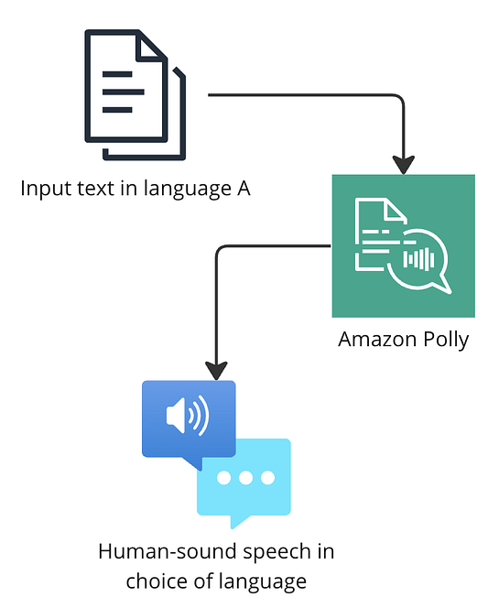

1. **Amazon Lex**:

Lex is a managed service that handles the development and deployment of conversational interfaces like chatbots. Comprehend can be used to extract insights like sentiments, entities or identify language from text.

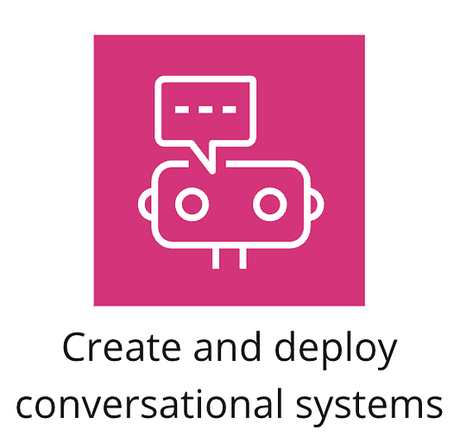

1. **Amazon Comprehend**:

A natural language processing (NLP) service that uses machine learning to uncover insights and relationships in text. It can identify the language, extract key phrases, places, people, brands, or events, understand how positive or negative the text is, and automatically organize a collection of text files by topic.



1. **Amazon Translate**:

Translates text between languages.

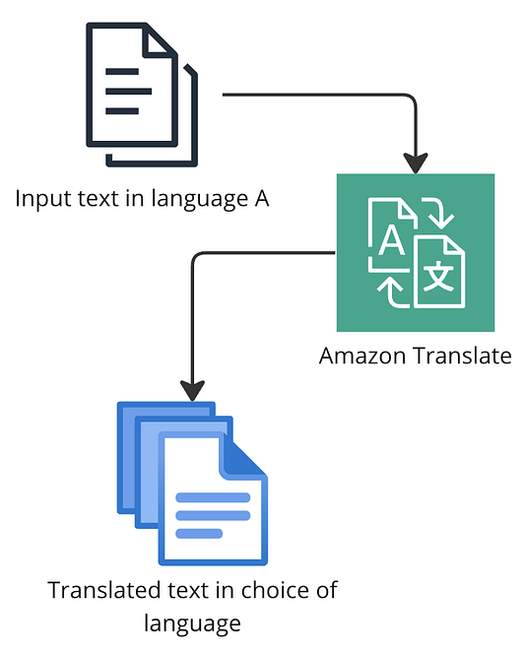

1. **Amazon Forecast**:

An AI service that delivers highly accurate forecasts using the same technology as Amazon.com. This service automatically discovers how variables such as product features, seasonality, and store locations affect each other, making it easier to prepare more accurate forecasts.



1. **Amazon CodeGuru**:

CodeGuru is a developer-friendly service that is used to automate code reviews. It specializes in generating intelligent recommendations for improving code quality.

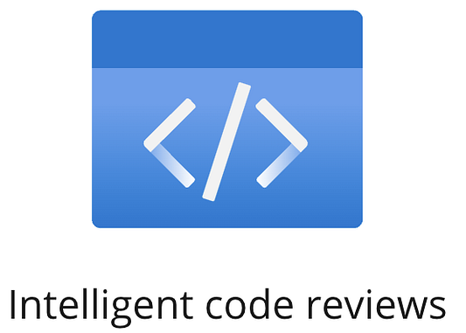

**ML services in AWS**

AWS offers distinct approaches to machine learning through its AI and ML services. While AI services leverage pre-built models for immediate use in applications, ML services provide tools for developers and data scientists to create, train, and deploy their own custom machine learning models. In this section we’ll delve into two significant AWS ML services: **Amazon SageMaker** and **Amazon CodeWhisperer**.

1. **Amazon SageMaker**:

**Functionality**: Amazon SageMaker is a fully managed service designed to facilitate the entire machine learning (ML) lifecycle, from building and training models to deploying them into production. SageMaker removes the heavy lifting from each step of the machine learning process to make it easier to develop high-quality models. It is integrated with Jupyter notebooks and is built to handle swift training and deployment of ML models. It can be used for designing predictive analytics, computer vision, and natural language processing applications.

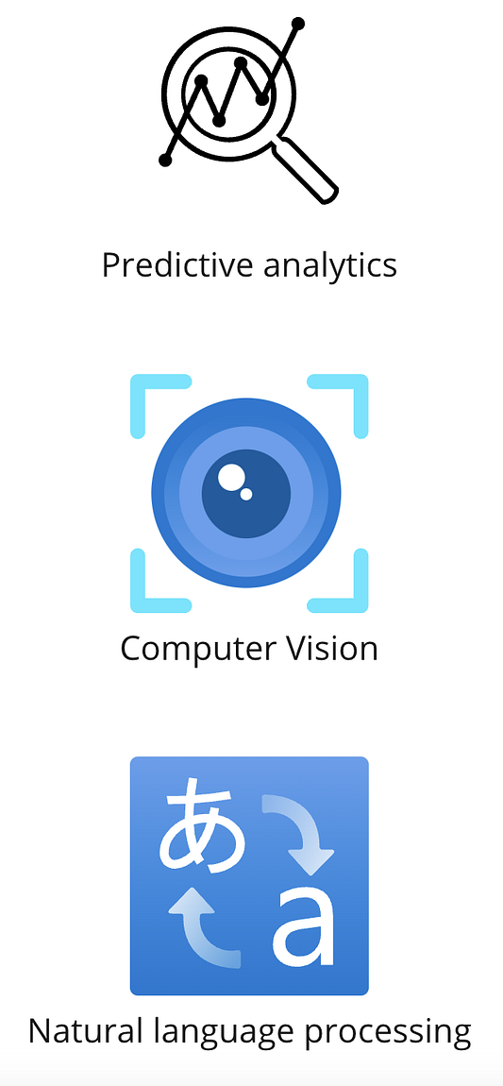Use cases of SageMaker

1. **Amazon CodeWhisperer**:

Amazon CodeWhisperer is a relatively newer service aimed at improving developer productivity with machine learning. It is a code generation service that helps developers by providing code recommendations based on their comments in real-time.

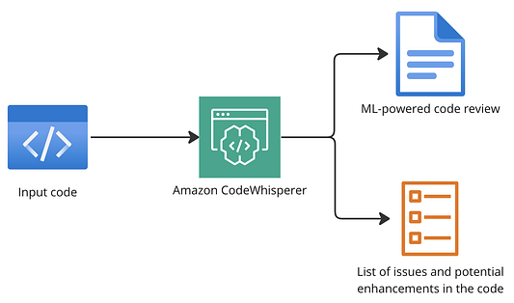This service significantly speeds up the development process, reduces the likelihood of bugs, and helps developers learn new APIs and languages by showing real-world coding practices.

**ML frameworks**

AWS supports a wide range of machine learning (ML) and artificial intelligence (AI) initiatives by offering access to several key open-source frameworks. These frameworks are essential for customizing and managing ML workflows, making it easier for developers and data scientists to deploy robust, scalable, and efficient ML models.

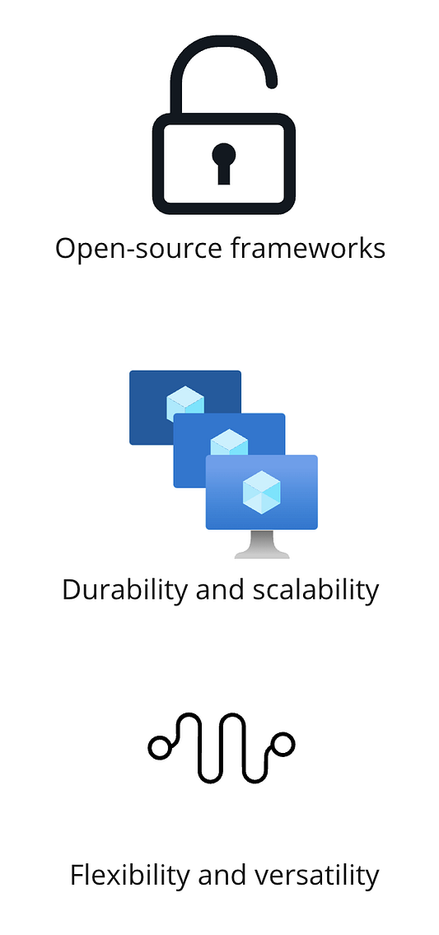Frameworks enable robust, scalable, and seamless deployment of ML models

**AWS ML Frameworks:**

1. **TensorFlow**: Developed by Google, TensorFlow is a versatile open-source library for numerical computation that makes machine learning faster and easier. It’s particularly strong in facilitating the development, training, and deployment of machine learning models across a variety of computing platforms.
2. **PyTorch**: Created by Meta (formerly Facebook), PyTorch is popular for its ease of use and flexibility, especially in academic and research settings. It excels in automatic differentiation, making it useful for applications that require on-the-fly adjustments to neural networks.
3. **MXNet**: Managed by the Apache Software Foundation, MXNet is renowned for its efficiency in training deep neural networks across distributed systems. This makes it ideal for environments where scalability and speed are crucial.

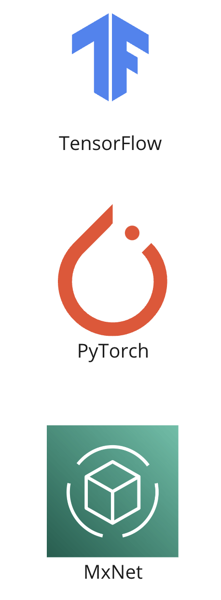

In the context of machine learning on AWS, a “pipeline” refers to a series of automated processes and workflows designed to manage the complete lifecycle of a machine learning model. This includes data collection, data preprocessing, model training, model evaluation, and deployment to production. The purpose of an ML pipeline is to ensure that the entire machine learning process is repeatable, scalable, and maintainable.

**Sample ML Pipeline Using AWS:**

1. **Data Preparation**: The process begins with the preparation of source data, which is stored in AWS S3, a scalable storage solution.
2. **Model Development and Training**: Using Amazon SageMaker, developers can directly read data from S3 to develop and train ML models. SageMaker provides a powerful platform that simplifies the entire lifecycle of machine learning from model building and training to deployment.
3. **Deployment**: Once the model is trained, the next step involves packaging the SageMaker notebook into a container. This container can then be deployed into a production environment using Amazon Elastic Kubernetes Service (EKS), which manages containerized applications.
4. **Continuous Integration**: AWS Lambda can be configured to trigger a re-training and deployment process whenever new data becomes available. This automation ensures that the ML model is always up-to-date and performing optimally.

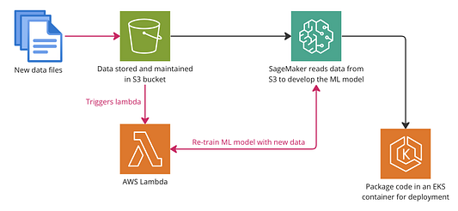This diagram illustrates the automated workflow of a machine learning pipeline on AWS. It starts with new data files being uploaded to an S3 bucket, which then triggers an AWS Lambda function. This Lambda function initiates the re-training of the machine learning model with the new data using Amazon SageMaker. Once the model is updated, it is packaged into an Amazon EKS container for deployment, ensuring that the ML model utilizes the most recent data for accurate and reliable predictions  
  
*********************************************************************************************************

### **Chapter 9**

### **AWS Analytics & BI Services**

AWS offers a comprehensive suite of Analytics and Business Intelligence (BI) services designed to help you make data-driven decisions efficiently.

**Introduction to data analytics**

Data analytics is the process of collecting, processing, and transforming large amounts of data to derive valuable insights. It’s an iterative process supporting continuous improvement.

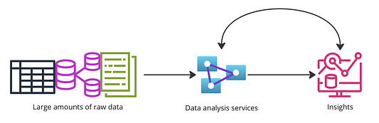This diagram illustrates the transformation of large volumes of raw data into actionable insights through AWS data analysis services. It represents the flow from data collection and storage, depicted by databases and spreadsheets, through processing via AWS data analysis tools, to the final output of valuable insights, symbolized by charts and graphs. This visualization captures the essence of how AWS enables businesses to harness data for strategic decision-making

In this section we’ll look at six aws services that facilitate data analytics workflows in AWS. These services are Athena, QuickSight, Kinesis, Redshift, Macie, and Glue.

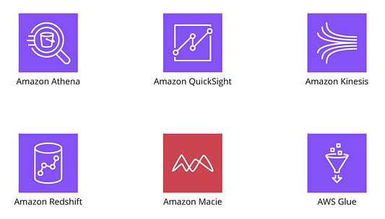

**Amazon Athena**:

Athena is a serverless query service that makes it easy to analyze data directly in Amazon S3 using standard SQL. It is cost-effective because you pay only for the queries you run, and it seamlessly integrates with other AWS services for both machine learning and data visualization, such as Amazon QuickSight.

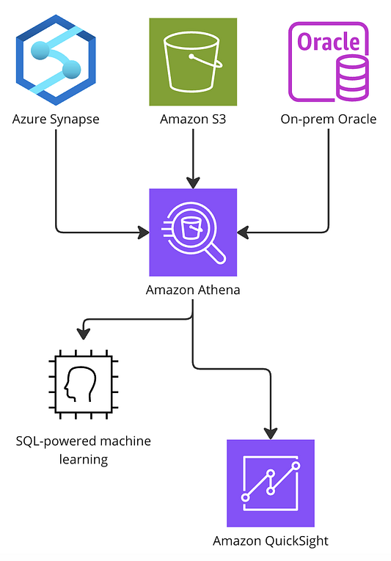This diagram illustrates a seamless data analytics workflow where Amazon Athena plays a central role. Data from diverse sources including Azure Synapse, Amazon S3, and on-premises Oracle databases are ingested into Athena. Athena’s powerful SQL capabilities allow for the analysis and processing of this data. The processed data then feeds into SQL-powered machine learning for predictive analytics and into Amazon QuickSight for creating visualizations and business intelligence reports. This setup showcases the integration of various data sources and AWS services to derive comprehensive insights and enhanced data-driven decisions.

**Amazon QuickSight**:

This is a scalable, serverless, embeddable, machine learning-powered BI service built for the cloud. QuickSight lets you create and publish interactive BI dashboards that include ML Insights. With serverless architecture, it automatically scales to handle large datasets and high concurrency without any infrastructure management. It comes with generative BI capabilities where you can put in natural language questions and it responds by building visualizations as answers.

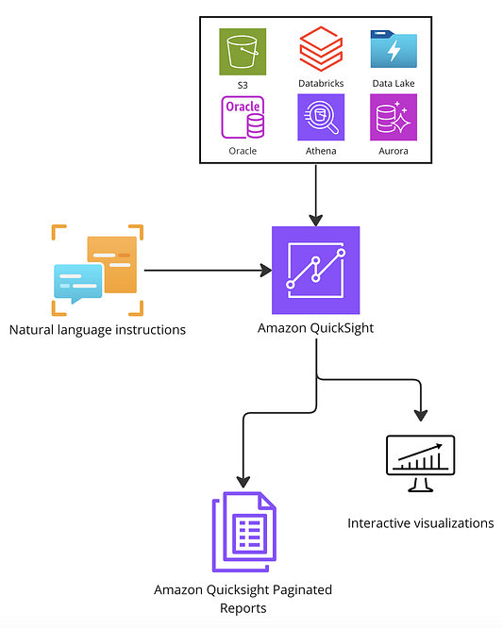This diagram showcases how Amazon QuickSight integrates data from multiple sources like Amazon S3, Oracle, Amazon Athena, and Amazon Aurora to facilitate comprehensive data analytics. Utilizing natural language instructions, QuickSight processes and analyzes the data to produce interactive visualizations and paginated reports. This workflow highlights QuickSight’s capability to generate dynamic BI content from diverse datasets, enabling businesses to make informed decisions quickly and efficiently.”

**Amazon Kinesis**:

Kinesis makes it easy to collect, process, and analyze real-time, streaming data. This enables developers to build applications that can continuously ingest and process large streams of data records in real time, which is ideal for time-sensitive information that must be processed quickly. Kinesis is serverless. is best used for real-time applications like live leaderboards, reading IoT-powered sensor data, and helps improve transfer speeds for traditional batch processing loads.

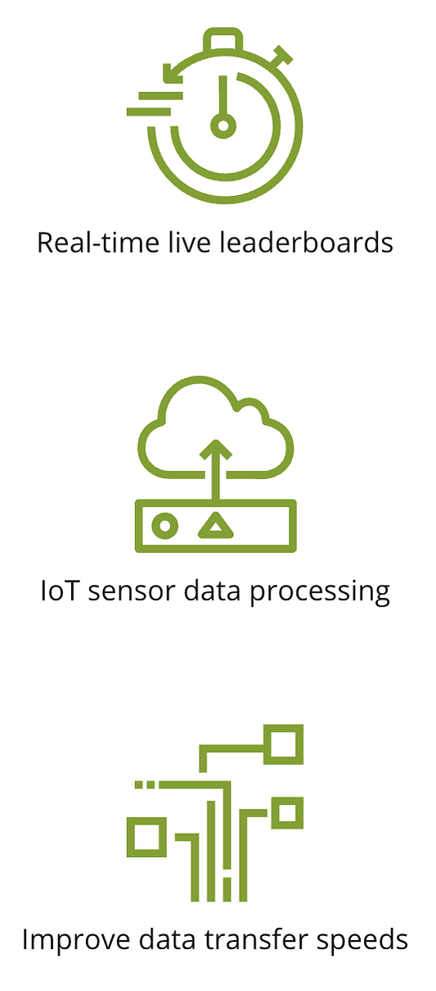Use cases of Kinesis

1. **Amazon Redshift**: Amazon Redshift is an AI-powered data warehousing service that supports massively parallel processing capabilities. Achieving high performance at six times lower cost, it supports zero-ETL (**Extract, Transform, Load)** for unified data integration, and enables secure parallel project collaboration. Redshift excels in data warehousing and advanced analytics, especially with large datasets, concurrent parallel processing, and monetizing data-as-a-service products.

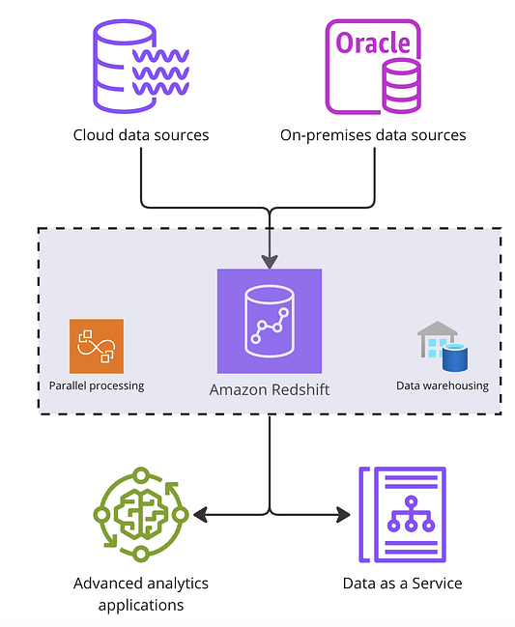This diagram shows how Amazon Redshift centralizes data from multiple sources, including cloud data sources and on-premises databases. Redshift facilitates parallel processing and efficient data warehousing, enabling advanced analytics applications and the provisioning of data as a service.

**Amazon Macie**:

Macie is an AI-powered security service that automatically recognizes sensitive data such as personally identifiable information (PII) and provides dashboards and alerts that help you understand how this data is being accessed or moved.

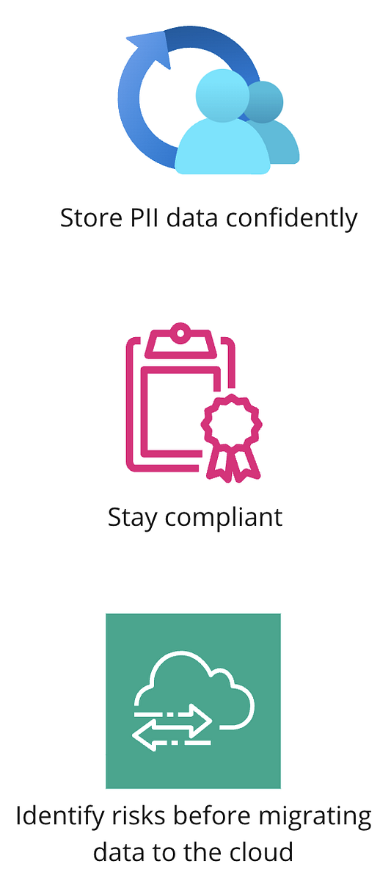This diagram highlights Amazon Macie’s role in ensuring data security and compliance. Macie uses machine learning to automatically discover, classify, and protect sensitive data stored in AWS, particularly Personal Identifiable Information (PII). It helps maintain compliance and secure data storage with capabilities for continuous monitoring and assessment of security risks.

**AWS Glue**:

Glue is a serverless data integration service that makes it easy to discover, prepare, and combine data for analytics, machine learning, and application development. It provides both visual and code-based interfaces to make data integration and ETL processes seamless and efficient.

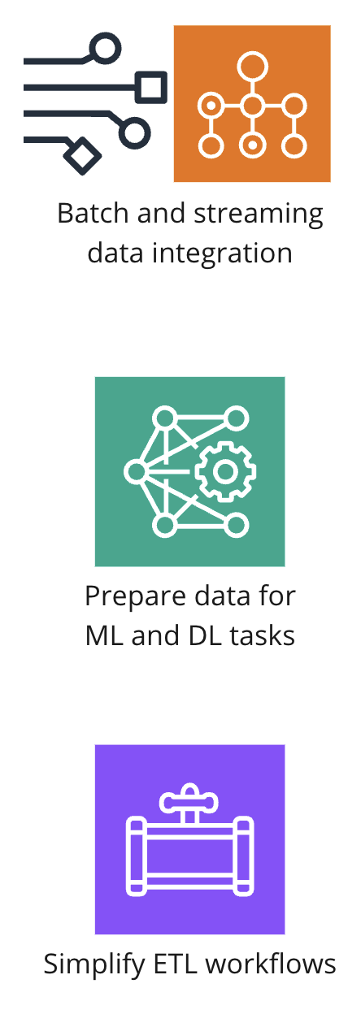Data Integration with AWS Glue: This diagram illustrates how AWS Glue streamlines data integration processes. Glue supports both batch and streaming data integration, prepares data for machine learning and deep learning tasks, and simplifies the development of ETL workflows. It automates data provisioning and integrates seamlessly between AWS services, enhancing the efficiency of data transformations and analytics workflows.

**Creating an end-to-end data workflow**

Now, let’s see how these analytics services work in action through a sample data analytics project in AWS. Imagine we are analyzing usage data from a mobile application.

* Data is ingested in real-time via Amazon Kinesis from sources like mobile applications and stored in S3.
* AWS Glue is used to transform and prepare data for analytics, moving it into services like Amazon Redshift and Athena for structured querying.
* Amazon Macie monitors data across S3, Redshift, and Athena to ensure sensitive information is protected.
* Analyzed data in Redshift might feed into machine learning models for advanced analytics.
* Results are visualized through Amazon QuickSight for interactive reporting and decision-making.

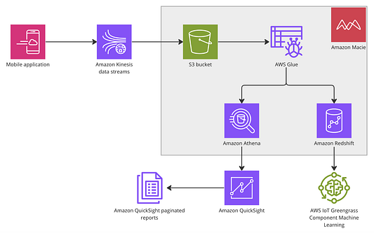This diagram illustrates a complex AWS data analytics workflow, starting from data collection to advanced processing and reporting. Data from a mobile application is first streamed via Amazon Kinesis, capturing and processing real-time data. The data is then stored in an Amazon S3 bucket, where AWS Glue facilitates the ETL processes. From there, data can be queried for insights using Amazon Athena or stored in Amazon Redshift for more complex analytics. For security, Amazon Macie monitors and protects the data throughout the process. Analyzed data feeds into Amazon QuickSight for creating paginated reports or visualizations. Additionally, AWS IoT Greengrass is utilized for deploying machine learning models to devices, enabling intelligent edge computing. This setup showcases the integrated capabilities of AWS services in handling, analyzing, and visualizing data effectively.

*********************************************************************************************************

**Chapter 10**

### **Secondary AWS Service Categories**

In this segment we’ll explore services that simplify your overall experience with AWS.

So far we have covered AWS services in global infrastructure, compute, storage, databases, networking, machine learning, and data analytics. These are the core offerings forming the foundation of cloud computing.

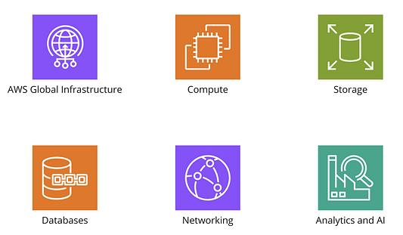Overview of core services in AWS

In addition to these, AWS offers a range of secondary services that complement and enhance the core functionalities, split into categories of business enhancement, developer tools, and advanced intelligence.

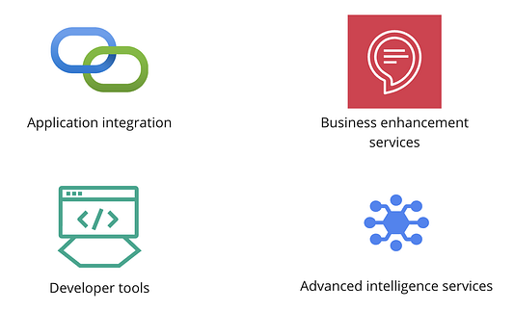Secondary service categories

Each category includes specific services that target different aspects of enterprise and application needs.

**Application Integration Services**

Amazon Simple Queue Service (SQS), and Amazon Simple Notification Service (SNS). These services act as orchestrators, ensuring seamless communication and data movement between applications, which is crucial for maintaining scalable architectures.

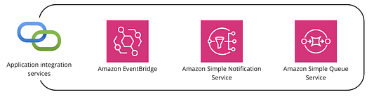

**Amazon EventBridge**

Amazon EventBridge responds to events within AWS or externally, connecting with all services to relay occurrences, freeing development from explicit dependencies. It also monitors your AWS environment, tracking integrations for improvement.

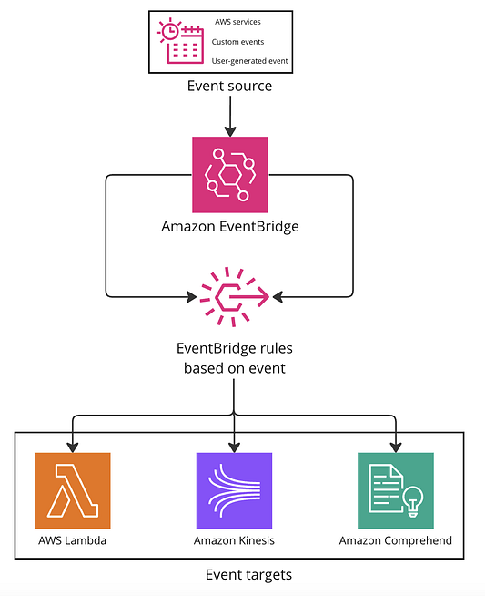This diagram illustrates how Amazon EventBridge acts as a central hub in an event-driven architecture, facilitating the routing of events from various sources to appropriate AWS services. Event sources can include AWS services, custom applications, or user-generated events. EventBridge processes these inputs based on defined rules and directs them to relevant targets such as AWS Lambda for function execution, Amazon Kinesis for real-time data streaming, or Amazon Comprehend for natural language processing. This setup exemplifies the flexibility and connectivity of EventBridge within AWS’s ecosystem, enabling sophisticated and scalable event handling mechanisms.”

**Amazon Simple Queue Service (SQS)**

Amazon SQS ensures reliable messaging between software components and scales almost infinitely. It is ideal for microservices communication, like dynamic GPS sensor feedback for updating live maps. It also efficiently decouples components for seamless background work.

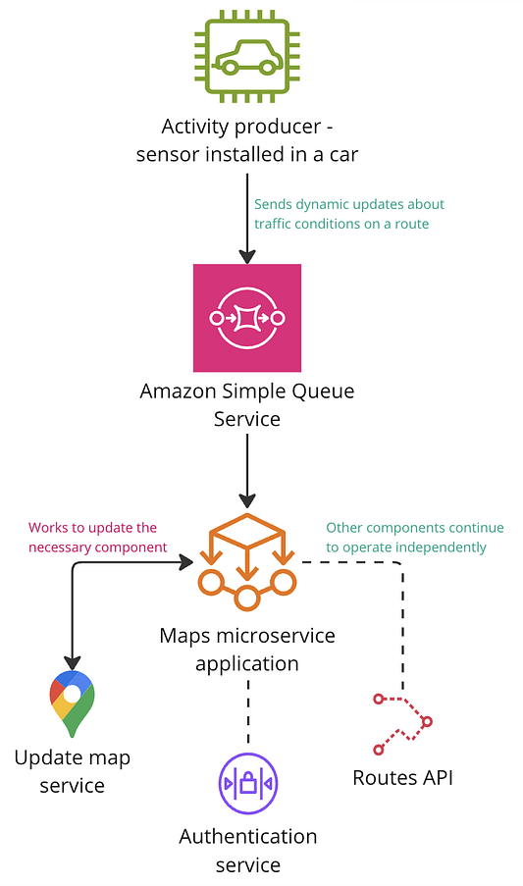“This diagram shows the role of SQS in processing real-time data from a car sensor, which acts as an activity producer, sending updates about traffic conditions. SQS queues these messages and ensures reliable communication to the map microservice application, which updates the mapping service accordingly. This workflow highlights SQS’s ability to handle high-volume messaging tasks efficiently, allowing other components like the Authentication service and Routes API to operate independently without being overwhelmed by direct traffic data streams.

**Amazon Simple Notification Service (SNS)**

SNS is a fully managed messaging service for both application-to-application (A2A) and application-to-person (A2P) communication. The service facilitates the sending of notifications to end-users using mobile push, SMS, and email, ensuring effective communication across different platforms.

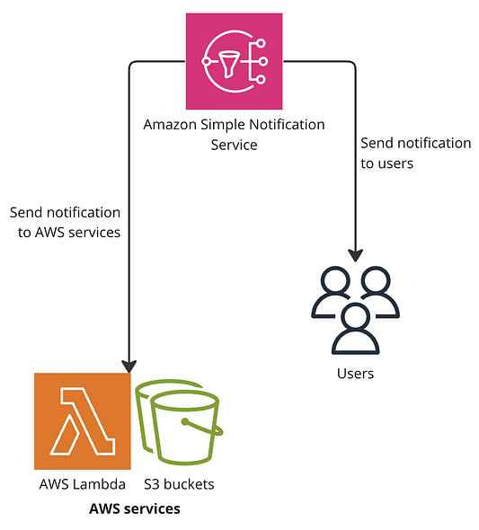

**Business Application Services**

Business application services streamline operations, increase efficiency, integrate with AWS services, and support automation.

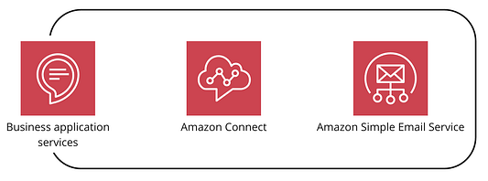

Services like Amazon Connect and Amazon Simple Email Service (SES) streamline operations by integrating with other AWS services, supporting business automation, and improving customer engagement through scalable contact center solutions and efficient email sending capabilities.

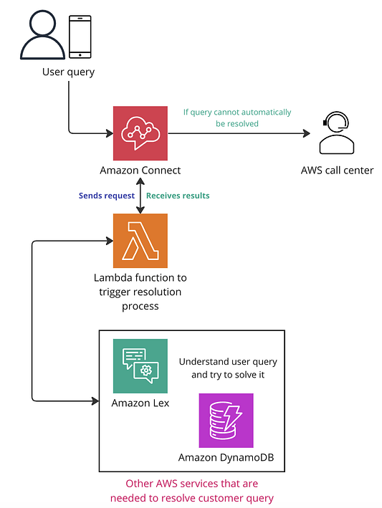This diagram illustrates a comprehensive AWS workflow for handling user queries through Amazon Connect. When a user submits a query via their mobile device, Amazon Connect first tries to resolve it. If the query cannot be automatically resolved, it is escalated to an AWS call center. Simultaneously, a Lambda function triggers the resolution process which involves using Amazon Lex for understanding and attempting to solve the query based on information stored in Amazon DynamoDB. This setup demonstrates the efficient use of AWS services to streamline customer support and enhance query resolution efficiency.

**Amazon Connect** is a cloud-based contact center offering easy setup and management. It scales customer support operations during peak times, ensuring efficient support with AI-driven features for personalized interactions and improved customer experiences.

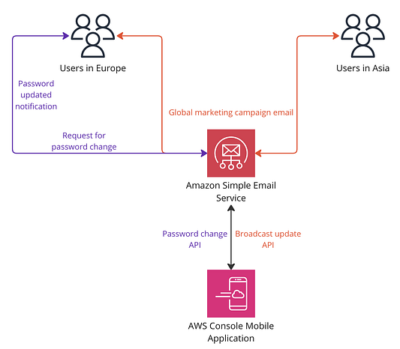his diagram showcases how Amazon Simple Email Service (SES) facilitates communication for global user bases across Europe and Asia. The process starts with users requesting a password change through the AWS Console Mobile Application. This request triggers the Password Change API, which interacts with Amazon SES to send password update notifications to European users and simultaneously launch global marketing campaign emails to Asian users. This illustrates the versatility of Amazon SES in managing diverse email communication needs efficiently and at scale.

Amazon SES is a scalable, cost-effective email service for marketing and transactional messages. It efficiently sends bulk emails, seamlessly integrates for transactional messages like password resets or order confirmations, providing reliable delivery and tracking capabilities.

**Developer Services**

AWS enhances developer productivity with services like AWS CodePipeline and AWS CodeCommit. These services support continuous integration and continuous delivery (CI/CD) practices, streamline code deployments, and facilitate collaboration across development teams.

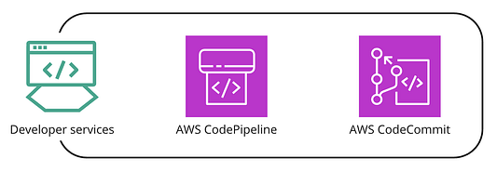

**AWS CodePipeline** is a continuous delivery service that automates the software release process, enabling developers to rapidly and reliably deliver features and updates. By using JSON templates, CodePipeline allows for flexible and easy modifications of the delivery pipelines, accommodating changes in the infrastructure or application workflow seamlessly. This service is designed to integrate with other AWS services, enhancing its capability to handle complex development workflows from code commit to deployment.

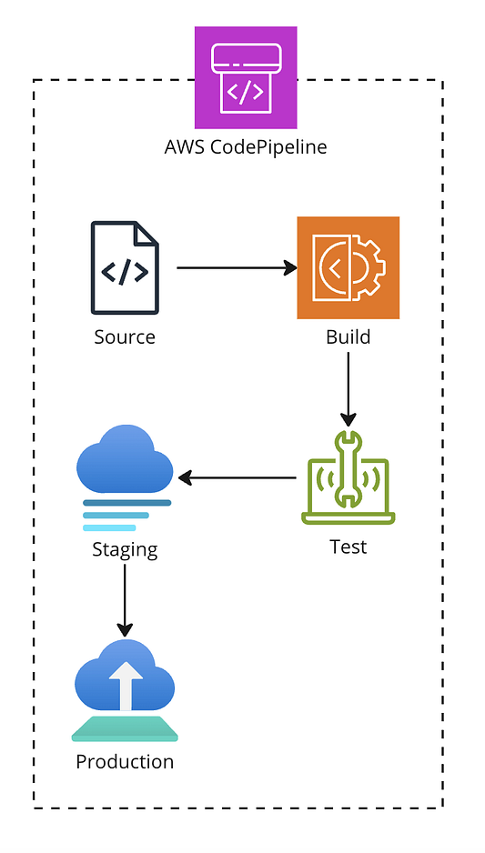This diagram illustrates the automated continuous delivery process facilitated by AWS CodePipeline. Starting with the source code retrieval, the process moves to the build phase where the code is compiled. After building, the code is deployed to a staging environment for testing. Once tested and verified, the final step involves deploying the production-ready application to the production environment. This streamlined workflow ensures that every piece of code is thoroughly tested and reviewed before it reaches the end-users, minimizing bugs and improving overall software quality.”

**AWS CodeCommit** is a fully managed source control service that provides private Git repositories within the AWS cloud. It’s designed to enhance the collaboration experience for developers by providing a secure and highly scalable ecosystem for code management.

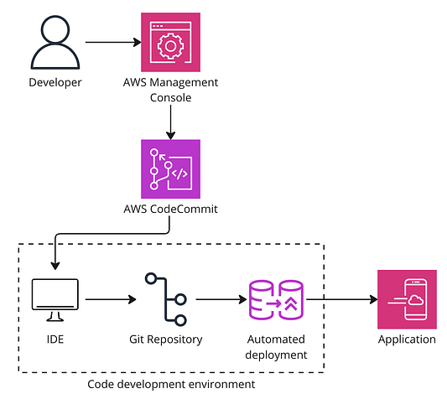This diagram illustrates the developer workflow facilitated by AWS CodeCommit. It starts with the developer using the AWS Management Console to manage and access the Git repositories within AWS CodeCommit. From there, code changes are pushed from the local Integrated Development Environment (IDE) to the CodeCommit repository. These changes are then automatically deployed to the appropriate environment, showcasing the seamless transition from code commit to deployment within the AWS ecosystem. This setup highlights the streamlined process of code management, review, and deployment using AWS services.”

**Advanced Intelligence Services**

AWS is pushing the boundaries of traditional computing with smart services like AWS IoT Core and Amazon Braket which connect directly with physical devices using the Internet of Things or perform supercomputer-level computations through quantum computing applications.

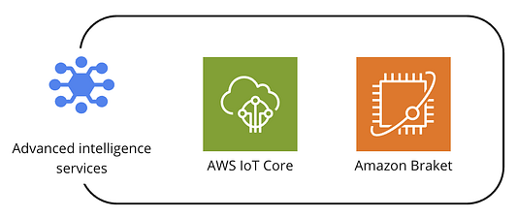

IoT Core enables the connection of IoT devices to the cloud for better management and integration, while Braket explores quantum computing applications, providing tools and environments to experiment with quantum algorithms. IoT Core is widely used for predictive maintenance and quality monitoring in industries, and also automates home IoT devices like thermostats and smart TVs. Braket provides essential tools and support for managing quantum projects, from code building to running and analyzing. It also supports automated testing for quantum applications.

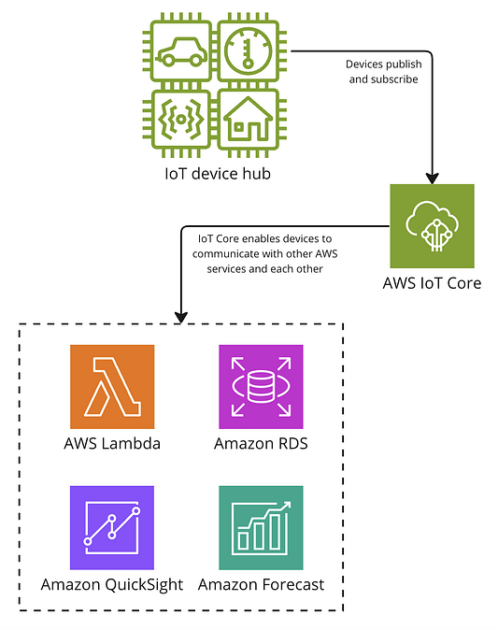This diagram showcases the connectivity and data flow enabled by AWS IoT Core, the central hub for managing IoT devices. Devices within the IoT device hub connect to AWS IoT Core, which facilitates their communication with other AWS services. This integration includes AWS Lambda for executing custom business logic, Amazon RDS for data storage, Amazon QuickSight for data visualization, and Amazon Forecast for predictive analytics. Together, these services streamline the process of data collection, processing, and analysis in IoT applications.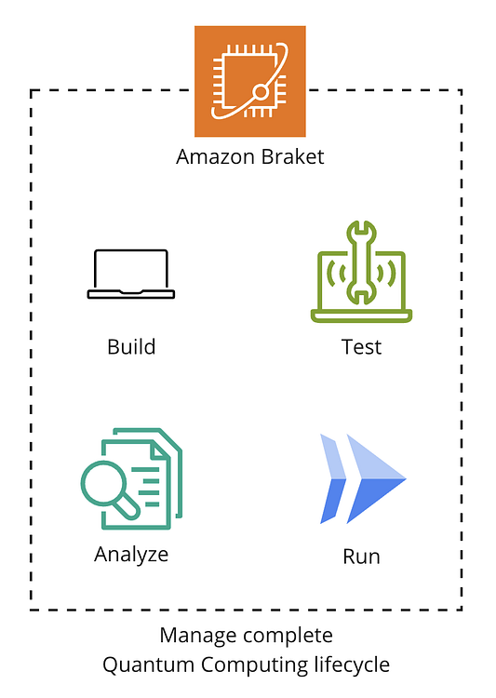This diagram illustrates the comprehensive workflow facilitated by Amazon Braket for managing quantum computing projects. It outlines the four key phases of the quantum development process: Build, where developers code quantum algorithms; Test, which involves simulating the quantum environment; Analyze, where the outcomes are evaluated for correctness and efficiency; and Run, executing the algorithms on quantum hardware. Amazon Braket provides the tools and environment necessary to manage each step of this lifecycle effectively.

**Refrences**

*Microservices*. (n.d.). smartbear.com.<https://smartbear.com/learn/api-design/microservices/>

*AWS Database Management & Compute Services — Containerized Deployments and Serverless Compute*. (n.d.). [Video]. DataCamp.<https://campus.datacamp.com/courses/aws-cloud-technology-and-services/aws-database-management-compute-services?ex=5>